Livestock sector and Food security-Prospects and Challenges

Dr.T.P.Sethumadhavan
Head, PublicationsDirectorate of Entrepreneurship
Kerala Veterinary and Animal Sciences University

Introduction
In the era of Globalization major structural reforms are taking place in the Animal agriculture. Livestock form an integral part of mixed farming systems, where they help to raise whole-farm productivity and provide a steady stream of food and revenues for households. Data in the FAO RIGA database (FAO, 2009a), which compiles information through surveys from 14 countries, indicate that 60 percent of rural households keep livestock. There is growing evidence to demonstrate that keeping poultry can enhance the food security of the poorest households, improving livelihoods and promoting gender equity (Ahuja and Sen, 2008; Ahuja, 2004; Dolberg 2004)

Fig(i)

India- Current scenario
Analysis of the trends over the last three decades indicates that the growth in poultry and dairy sectors has exceeded the growth in cereal production. This may be due to rapid urbanization, population growth, rising levels of income, changing food habits and varying prices of livestock products. There are certain indications, which suggest that the demand led livestock growth is expected to continue and by 2020 more than 60 percent of meat and 50 percent of milk will be produced in the developing countries. Fig (i).

Fig(ii)

As global economic recession and food security issues are acquiring momentum, Government of India has identified livestock sector as one of the sustainable areas. Fig(ii) The pace of shift of Indian Livestock sector from traditional to market system is a gradual process which contributes 33 percent of the total income from agriculture. Annual growth rate in livestock sector is more than four times in agriculture. Commodity share is 3.53 as against 3.5 in agriculture. More than 75 percent of the rural households in India depend on livestock sector for supplementary income and women carry out 90 percent of the activities related to care and management of livestock.
Even though India is the largest milk producing country in the world, Productivity per animal is only less than 50 % of the world average. This is mainly due to poor level of nutrition and low genetic potential for milk production and health care. Projected gap between demand and supply of green and dry fodder presents a challenge for fodder production in the coming years. Demand elasticity estimates of Indian dairy industry for milk and milk products combined are 1.65 in rural and 1.15 in urban India. (Dutta and Ganguly 2000). Moreover expenditure elasticity of demand for milk and milk products for lower income class is considerably greater. Moreover of the total daily income, an Indian spends 40 percent for food, of which he is spending nearly 26 percent for purchasing animal protein sources when compared to 24 percent for vegetable protein sources. As domestic consumption of milk increases, wide demand supply gap arises. Even though consumption of food grains has decreased, animal protein sources like milk, meat and eggs show a positive trend. This emphasizes the need for increasing domestic production to meet the ever-increasing need for animal protein sources.
How poor will benefit from the increasing consumption of livestock products will depend on a number of policy, technology and research choices. There is evidence from several countries that small holders are very competitive under the right circumstances (Delgado et al 2001).

Demand supply mismatch
Globally protein malnutrition is the major issue affecting food security. Animal protein is the cheapest source through which food security can be achieved easily. A wide gap exists between the requirement and availability of animal protein sources in the state.
Rapidly increasing demand for livestock products, along with the changes in international trade, is placing pressure on India's livestock sector both to expand and adapt. This adaptation takes the form of two major shifts - a shift in livestock functions and species, and a shift in agro-ecological and geographical zones, involving structural and technological changes.
Today, non-food functions of livestock are generally in decline and are being replaced by cheaper and more convenient substitutes. At the same time, the asset, petty cash and insurance functions of livestock are being replaced by financial institutions as even remote rural areas enter the monetary economy. Due to mechanization, animal as draught power is declining. Manure continues to be important in mixed farming but its role in overall nutrient supply is diminishing because of the competitive price and ease of management of inorganic fertilizer. Although demand for natural fibres is high, there are a growing number of synthetic substitutes for wool and leather.
Recently there is an increasing selectivity to the parts of the animal used for food. Now the trend is towards lean meat, and other products - such as offal, blood and bone - are being used industrially, or recycled as feed. Thus, there is a trend from multi-purpose to single purpose animals, with animal protein the overriding objective. This is also reflected in the choice and manipulation of genotypes, which favor specialization over product diversity. Another trend is the growing importance of monogastrics as economic converters of concentrate feed.
Livestock production is growing faster in the moist parts of the region, and it is moving closer to urban settlements. In Asia, as in the rest of the world, it is the humid and sub-humid zones that still offer a large potential for agricultural production. Human populations are increasing over-proportionally in these areas while other zones, such as arid and highland areas have reached a level of population density above which significant increases can no longer be sustained. Livestock populations are increasing faster in the moister areas than in other zones.
To some extent, this can be explained by a continued close integration of animals in mixed systems. More importantly, however, this phenomenon reflects the increasing "urbanization" of livestock production, influenced by urban demand, good market access and adequate infrastructure. This type of livestock production is largely independent of agro-ecological conditions and far outpaces other land-based systems.
This trend is in line with the observed shift to monogastric species and poultry. In some rural areas, the lack of infrastructure, economies of scale and insufficient marketing facilities face heavy competition from urban production, so that livestock production is limited to subsistence levels. This trend towards urbanization is clearly not sustainable in the long term, mainly because of waste disposal and environmental problems as well as public health implications.
Structural changes. Two important structural changes apply across production systems: a general growth in scale and a trend away from horizontal to vertical integration. Levels of livestock production and processing are increasing in response to technological development, market requirements and insufficient returns to labour in traditional systems. Where alternative employment opportunities exist, such as in the rapidly industrialized countries of the region, traditional subsistence-orientated livestock farming is often abandoned, opening up market and expansion opportunities for other farmers or commercial entrepreneurs.
In particular, poultry production has often developed from a simple farm operation to a complex vertical operation of related industries and enterprises, including grain production for animal feeds, feed mills, slaughterhouses and processing plants, food chain stores and wholesale enterprises.
Further structural changes relate to the new trends in the importance of different production systems. The growth potential for extensive grazing and roughage production is limited. In response to increased population pressure, good pastureland is being converted into cropland, leaving increasingly poorer land for grazing and mixed farming. Industrial production of pigs and poultry is therefore increasing relative to production from grazing and mixed farming systems. Pork and broiler production will also increase relative to ruminant meat production. This is a direct result of the better conversion efficiencies of concentrate feed in pigs and poultry.
Faced with increasing resource constraints that stem from a small land base, countries resort to importing meat and other livestock products to satisfy the growing demand. This is evidenced by a growing trade deficit in these products. The developing countries of Asia had a net trade deficit of 313,000 tons of ruminant meat and a net trade surplus of 409,000 tons of monogastric meat. While the region as a whole is self-sufficient in all livestock products, there are important differences between the sub-regions. Australia and New Zealand make up for the deficit of the other sub-regions, particularly for beef and milk.
Technological changes. In line with the structural changes outlined above, the development, transfer and adaptation of technologies will focus on improving efficiency of feed utilization and increasing animal productivity. Feed requires land for production and this continues to be the limiting factor to the sector's expansion even if countries resort to feed imports. Continuing industrial development in the region will also make traditional livestock raising practices less competitive because of diminishing returns to labour, even though this process will be very gradual.
We are therefore witnessing a dualistic mode of development, with two conflicting components. First, a modern, demand-driven and capital-intensive sector, producing poultry meat, eggs, pork, and sometimes milk, increasingly uses state-of-the-art technologies. It is rapidly expanding to meet urban demand but it is also susceptible to market upheavals; it generates little employment, poses great environmental risks because it tends to concentrate in areas with good market access, and it creates a number of new challenges for human and veterinary public health. Technology uptake has been fast, driven by commercial interests. At the same time, a traditional, resource-driven and labour-intensive sector continues to provide a multitude of services to subsistence-oriented farms. While not efficient in terms of introduced inputs, this sector uses resources of little or no alternative uses, and for the same reason, its potential to expand beyond moderate growth rates is constrained by low technology uptake, insufficient market facilities and infrastructure, and small economies of scale. Often, these systems are closed cycles of nutrients, farm labour, energy, etc. Unless these cycles are broken, technology uptake will remain constrained.
Production system pathways. Livestock systems develop in response to resource endowment and market opportunities. Grazing systems have limited scope for expansion. Mixed farming systems will see continued intensification and important growth, with livestock based on crop by-products and surplus. Some productivity gains can be achieved by further enhancing nutrient and energy flows between the crop and livestock component. Mixed farming system may be threatened by the disappearance of livestock, triggered by population pressure, fragmentation of arable land, poverty and lack of market access.
Under more favorable agro-ecological and market conditions, industrial systems have emerged, in parallel with, and sometimes supplanting, mixed farming systems. Because of generally poor infrastructure and institutions, these are usually established close to demand centers, resulting in excessive animal densities, nutrient surpluses and other environmental and human health problems that highlight an "urban trap": while profitable in the short run, these systems cannot be sustained in urban or peri-urban environments. Such considerations caused, for example, Singapore, to abandon livestock production altogether. The answer is to allow specialized commercial production to operate in an area-wide concept where nutrient balances are maintained and the land's capacity to absorb animal waste is respected.
Emerging diseases. Avian influenza, Classical Swine Fever and Bovine Spongiform Encephalopathy ("Mad Cow Disease").
Often it is more economically attractive to protect only the more intensive production units in proximity to markets. Model for developing countries? It is against this background that we must examine more closely the ongoing trend towards the intensification of livestock production. We may take, as an extreme example, the intensive animal production in the Netherlands, where some 20 million pigs and cattle are confined on a land area of about 33,000 sq km and where milk output alone is equal to that of the whole of developing Africa.
Challenge for policymakers. Interactions between livestock and the environment are many and complex - a challenge for policymakers for whom socio-economic factors are likely to be far more pressing and politically sensitive. Putting the environment in the forefront does not mean that only environmental objectives count. On the contrary, environmental goals can only be effectively tackled if accompanied by sound economic policies.
Opportunities to tap the immense development potential that livestock offer, while nevertheless minimizing environmental damage, are many. Awareness, political will and readiness to act are growing among all those involved and should ensure that the problems are no longer ignored but effectively tackled.
2.5 Market led production programme
While giving emphasis to production, marketing of the livestock products were not given due attention. Scientific breeding, feeding, management and disease control has been given due importance. When the issue of sustainability arises marketing will come in to picture. Livestock products except around 15 % of the milk produced are mainly traded through unorganized sector. In order to explore the rural market for livestock products, production strategy need to be market oriented in nature. Fig (iii). It should be in tune with local, domestic and international market. Production and branding of traditional livestock products, which fetches good price, should be promoted. Changes in the extension approach, market forecasting system, value addition, awareness on diseases affecting trade of livestock products, consumer behavior, production of livestock products based on the demographic characteristics of the population, good manufacturing and retail practices, best production practices and implementation of food safety norms, branding, etc need more emphasis. As told by the world marketing Guru Philip Kotler in today’s world of IT explosion, branding is becoming more important than before. One needs to redefine the role of marketing as creating, communicating and delivering value to the consumer. Value addition of livestock products should be based on consumer needs and taste, like fat free milk for cardiac patients, chocolates for children, quality cheese for international market, etc.
Fig(iii)

2.11 Knowledge dissemination
Considering the efficient decentralized administrative setup of the state, the livestock delivery and the knowledge dissemination pathway can be studied at the Panchayat, district and state level. All the Veterinary institutions are having Animal husbandry information centers. Print and electronic media in the state are regularly publishing, telecasting/broadcasting information required for the livestock farmers in their Agriculture column/journals/programmes
Based on different pathways for knowledge transfer which already exist in the system, existing level of livestock information gained by the farmers, level of knowledge required for sustainable results and level of existing knowledge gap a concept model to fill the knowledge gap can be designed.

Fig (iv)

References
1. Livestock’s long shadow-Environmental issues and Options FAO2006
2. Abuja (2004) .The economic rationale of public and private sector roles in the provision of animal health services.Rev.sci.tech.off.int.Epiz.23 (11-33-45)
3. Garforth, C. (2004) Strategies for effective dissemination of animal health knowledge. Presented in the workshop “Dissemination of Animal Health Knowledge” conducted on 11th and 12th march, 2004.
4. Ahuja.V.J, Morrenhof and A.Sen (2003). The delivery of Veterinary services to poorer communities; the case of rural Orissa, India.Rev Sci.tech.Off.int.Epiz.22(3) 931-948
5. Heffernan, C. (2003). Delivery of veterinary services to the poor: Findings from Pondicherry, India.
6. Ramkumar, S and Rao, S.V.N. (2003) Cattle rearing by the landless in the Peri-urban regions of Pondicherry:Anoverview.

Case Study Methodology

Dr.B.Ashok IAS
Vice Chancellor
Kerala Veterinary and Animal Sciences University

Introduction
The case study method of teaching used in Public Policy and Management (PPM) education is quite different from most of the methods of teaching used at the school and undergraduate course levels. Unlike traditional lecture-based teaching where student participation in the classroom is unidirectional and minimal, the case method is an active learning method, which requires participation and involvement from the student in the classroom. For students who have been exposed only to the traditional teaching methods, this calls for a major change in their approach to learning. Without a paradigm shift from both instructors and learners and focus on pre-class intensive preparation, case method will not yield optimal results. This collection of cases is intended to provide students with some basic instruments on the case method, and a few selected cases. We begin by taking a brief look at what case studies are, and how they are used in the classroom. Then we discuss what the student needs to do to prepare for a class, and what she can expect during the case discussion: We consider the benefits a student of PPM can expect to gain through the use of the case method.

What is a Case Study?
There is no universally accepted definition for a case study, and the case method means different things to different people. Consequently, 2 Indian Public Management : Case Studies for Good Governance all case studies are not structured similarly, and variations abound in terms of style, structure and approach. Case material ranges from small caselets (a few paragraphs to one or two pages) to short cases (four to six pages) and from 10 to 18 page case studies to the longer versions (25 pages and above). A case is usually a “description of an actual situation, commonly involving a decision, a challenge, an opportunity, a problem or an issue faced by a person or persons in an organization. In learning with case studies, the student must deal with the situation described in the case, in the role of the manager or decision maker facing the situation.

Multiplicity of Solutions
An important point to be emphasized here is that a case is not a problem. A problem usually has a unique, correct solution. On the other hand, a decision-maker faced with the situation described in a case can choose between several alternative courses of action, and each of these alternatives may plausibly be supported by logical argument. To put it simply, there is no unique, correct answer in the case study method.
The case study method usually involves three stages: individual preparation, small group discussion, and large group or class discussion. While both the instructor and the student start with the same information, their roles are clearly different in each of these stages.

Case Studies in the Classroom
Case studies are usually discussed in class, in a plenary group. However, sometimes, instructors may require individuals or groups of students to provide a written analysis of a case study which may or may not be graded, or make an oral presentation on the case study in the classroom.

Preparing for a Case Discussion
Unlike lecture-based teaching, the case method requires intensive preparation by the students, before each class. If a case has been 3 assigned for discussion in the class, the student must prepare carefully and thoroughly for the case discussion. It is ideal if the case study discussion class is preceded by a reading recess.
The first step in this preparation is to read the case thoroughly. To grasp the situation described in a case study, the student will need to read it several times. The first reading of the case can be a light one, to get a broad idea of the story. The subsequent readings must be more focused, to help the student become familiar with the facts of the case, and the issues that are important in the situation being described in the case — the who, what, where, why and how of the case. However, familiarity with the facts described in the case is not enough. If necessary the student must also acquire a thorough understanding of the case situation, through a detailed analysis of the case using secondary web/library resources. During the case analysis process, the student must attempt to identify the main protagonists in the case study (organizations, groups, or individuals described in the case) and their relationships.
The student must also keep in mind that in the different kinds of information are presented in the case study. There are facts, which are verifiable from several sources. There are inferences, which represent an individual’s judgment in a given situation. There is speculation, which is information which cannot be verified. There are also assumptions, which cannot be verified, and are generated during case analysis or discussion. Clearly, all these different types of information are not equally valuable for decision-making. Usually, the greater your reliance on facts (rather than speculation or assumptions), the better the logic and persuasiveness of your arguments and the quality of your decisions. Sometimes data is over supplied to confuse the student. A careful selection of facts to be used to take decisions is also crucial.

Broadly speaking, the different stages in the case analysis process could be as follows:
1. Gaining familiarity with the case situation (critical case facts, persons, activities, contexts);
2. Recognizing the symptoms (what are the things that are not as expected, or as they should be?);
Case Study Methodology
4 Indian Public Management : Case Studies for Good Governance
3. Identifying goals/objectives;
4. Conducting the analysis;
5. Making the diagnosis (identifying problems, i.e. discrepancies between goals and performance, prioritizing problems, etc.);
6. Preparing the action plan (identifying feasible action alternatives, selecting a course of action, implementation planning, plan for monitoring implementation).

Case Discussions in the Classroom
A classroom case discussion is usually guided by the instructor. Students are expected to participate in the discussion and present their views. In some cases, the instructor may adopt a particular view, and challenge the students to respond. During the discussion, while a student presents his point of view, others may question or challenge him. Case instructors usually encourage innovative ways of looking at and analyzing problems, and arriving at possible alternatives. The
idea is to develop multiple narratives and conflicting view points of the same set of facts. The interaction among students, and between the students and the instructor, must take place in a constructive and positive manner. Such interactions help to improve the analytical, communication, and interpersonal skills of the students. However, some control has to be exercised to focus on the pre-identified core issues especially in the latter 40 per cent of time allotted use of Flip charts and white boards to post the “Core issues” is ideal to focus discussion. Students must be careful that the contributions they make to the discussion are relevant, and based on a sound analysis of the information presented in the case. Students can also refer to the notes they have prepared during the course of their preparation for the case discussion. While open humorous phases are welcome initially, one will have to focus on learning points sooner or later. Case study needs excellent and control capability of instructors. The instructor may ask questions to the class at random about the case study itself or about the views put forward by an individual student. If a student has some new insights about the issues at hand, she is usually encouraged to share them with the class. Students must respond when the instructor asks some pertinent 5 questions. The importance of preparing beforehand cannot be emphasized enough — a student will be able to participate meaningfully in the case discussion only if he is knowledgeable about the facts of the case, and has done a systematic case analysis. A case discussion may end with the instructor (or a student) summarizing the key learning points (or ‘takeaways’) of the session. Many instructions circulate, after a first round of discussion ‘a pre-prepared’ points for discussion. Student performance in case discussions is usually evaluated, and is a significant factor in assessing overall performance in the course. The extent of participation is never the sole criterion in the evaluation — the quality of the participation is an equally (or more) important criterion. The ability to ask pointed questions and ‘deepen the debate’ is a key criteria while evaluating student performance.

Working in a Group
If a group of students is asked to analyze a case, they must ensure that they meet to discuss and analyze the case, by getting together for a group meeting at a suitable time and location. Before the meeting, all the team members must read the case and come with their own set of remarks/observations.
The group must ensure that all the group members contribute to the preparation and discussion. It is important that the group is able to work as a cohesive team — problems between team members are likely to have an adverse impact on the group’s overall performance.

Preparing a Written Case Analysis
Quite often, a written analysis of the case may be a part of the internal evaluation process. When a written analysis of a case is required, the student must ensure that the analysis is properly structured.
An instructor may provide specific guidelines about how the analysis is to be structured. However, when submitting an analysis, the student must ensure that it is neat and free from any factual, language and grammar errors. In fact, this is a requirement for any report that a student may submit — not just a case analysis. Most courses will require this to be in work procured or excel format.
Case Study Methodology
6 Indian Public Management : Case Studies for Good Governance

Making a Case Presentation

The instructor may ask a group of students to present their analysis and recommendations to the class. Alternatively, an individual student can also be asked to make a presentation. The key to a good presentation is good preparation. If the case has been studied and analyzed thoroughly, the content of the presentation should present no problems. However, a presentation is more than the content. Some of the points that need to be kept in mind when making a case presentation are:
❑ As far as possible, divide the content uniformly so that each team member gets an opportunity to speak.
❑ Use visual aids such as OHP slides, Power Point presentations, advertisement/press clippings etc., as much as possible to advance the agreement.
❑ Be brief and to-the-point. Stick to the time limits set by the instructor. Do not allow a few participants to monopolize the discussion. Set ground rules that participants do not speak
for more than 2 minutes at a speech.
❑ Be well prepared.

Evaluating Student Performance
The evaluation of a student’s performance in a case-driven course can be based on some or all of the following factors:
❑ Written case analyses (logical flow and structuring of the content, language and presentation, quality of analysis and recommendations, etc.).
❑ Case presentations (communication skills, logical flow and structuring of the content, quality of analysis and recommendations, etc.).
❑ Participation in classroom case discussions (quality and extent of participation).
❑ Case writing assignments or similar projects.
❑ Case-based examinations.

Benefits from the Case Method
The case method has several advantages over traditional teaching methods. The skills that students develop by being exposed to this method are many and are described below. The consequences to the student from involvement in the method are listed thereafter.
❑ Cases allow students to learn by doing. They allow students to step into the shoes of decision-makers in real organizations, and deal with the issues public managers face, with no risk
to themselves or the organization involved.
❑ Cases improve the students ability to ask the right questions, in a given problem situation. Their ability to identify and understand the underlying problems rather than the symptoms of the problems is also enhanced.
❑ Case studies expose student’s to a wide range of industries, organizations, functions and responsibility levels. This provides students the flexibility and confidence to deal with a variety of tasks and responsibilities in their careers. It also helps students to make more informed decisions about their career choices.

Results of Case Based Learning
❑ Cases studies strengthen the student’s grasp of management theory, by providing real-life examples of the underlying theoretical concepts. By providing rich, interesting information about real business situations, they breathe life into conceptual discussions.
❑ Cases provide students with an exposure to the actual working of business and other organizations in the real world.
❑ Case studies reflect the reality of managerial decision-making in the real world, in that students must make decisions based on insufficient information. Cases reflect the ambiguity and complexity that accompany most management issues.
❑ When working on a case study in a group, students must also be able to understand and deal with the different viewpoints and perspectives of the other members in their Case Study Methodology
8 Indian Public Management : Case Studies for Good Governance team. This serves to improve their communication and interpersonal skills.
❑ Case studies provide an integrated view of management. Managerial decision-making involves integration of theories and concepts learnt in different functional areas such as marketing and finance. The case method exposes students to this reality of management.

Source: 1993, C.C. Lundberg and C. Enz, ‘A Framework for Student Case Preparation’, Case Research Journal, 13 (Summer) 134/Michael A. Hitt, R. Duane Ireland and Robert E. Hoskisson, Strategic Management (Thomson Southwestern, 6th Edition) Cii as adapted.

LANDLESS LIVESTOCK FARMING:
REVISITING THE SITUATION FOR EFFECTIVE SERVICE DELIVERY

Prof. S. Ramkumar. MVSc, PhD (UK)
Director, Entrepreneurship
Kerala Veterinary and Animal Sciences University

- INTRODUCTION
The livestock economy of India is largely the domain contributed by the landless, marginal and small livestock owners focusing on dairying. The contribution of the landless and less land families to the country’s total milk production is substantial (Shukla and Brahmankar 1996, De Leeuw et. al 1999, Ahuja et. al 2000, Datta 2002). Almost 70% of the dairy farmers in India are either landless or small/marginal farmers, who own only one or two cattle. Landless families who depend on livestock for some or all of their livelihood form a relatively large proportion in India (Ørskov, 1993). The major share of the credits for India’s position as the largest milk producing country in the world and the significant increase in the per capita availability of milk in the country has to go to the largely illiterate rural women dairy farmers (Patel 1998). The approximate contribution of dairying to the total income range from 50% to 80% in the cattle owning families in all the four states viz Tamil Nadu, Kerala, Andhra Pradesh and Karnataka (Ramkumar and Rao 2001).
People who rear one or two cows/buffaloes, majority of whom are women are the real contributors to this economy. For majority of them, cattle rearing is their livelihood option, aiding them to move out of poverty, not only by the daily cash income they receive from milk (on which they have better control) but also by giving them better confidence in life, through its value as an asset (Ramkumar et al, 2003). A cow/buffalo is an economic resource of a family: however, possession of dairy animals means more than increased income; it means status, self-confidence and an opportunity to take some control over one’s own life. The women have a greater power on the control over this resource, compared to others, like the land in the village. The ownership of this asset increases the confidence and self-worth of women (Ramaswamy et.al, 1999). It opens up to them an occupation that generates more value both economically and socially. The science of the livestock economy needs to be viewed in this perspective. The not-so-visible roles of cattle rearing are the areas that usually decides the adoption of technologies.
75 million women and 15 million men are engaged in dairying in India. Of the 90 million engaged in dairying, 75 million are women; with a modest family size of three, dairying thus influences the development of at least 270 million people in India.
By raising incomes, an apparently simple single commodity project can have multiple beneficial effects, including nutrition, education (especially of girls), and job creation (Candler and Kumar, 1998), and in rural transformation (GOI, 2004). Rearing milch animals gives a new life to the landless households who are deprived of other resources for prosperity (Sreeramulu, 2001). It offers the only alternative for many a landless family who are mostly unskilled and illiterate.
The purpose of this paper is to briefly look into the context and concerns in the sector of landless livestock rearing with a focus on dairy cattle rearing so as to understand the research and extension priorities in this sector.

- UNDERSTANDING THE CONTEXT OF LANDLESS LIVESTOCK FARMING:
Various changes that have happened (and is happening) have influenced the context of landless livestock rearing. Of these few significant ones are given below:

02.1. Agrarian changes
Increase in the pressure on the land due to urbanization, industrialization and land fragmentation the average landholding is falling. Crop production is not being considered as a viable sole enterprise especially among the small landholders. Even the so-called "farming families" who own large holdings are entering into the industrial sector or non-farm business as the latter appears to be more lucrative. However, many absentee landlords are retaining their fields by switching production from paddy or wheat to less labour intensive and risk prone cultivation. In Pondicherry, Casuarina plantations offer security of the land and needs little in the way of supervision and labour. In many other places the areas are being used for constructions: generally industrial, residential and educational purposes.

02.2 Redistribution of cattle among poor

Even though the livestock census shows a decreasing trend in the total cattle population in some states, the herd size of the landless shows a marginal increase. The number of landless cattle owners is increasing due to marginalization of small and marginal farmers. There is clear disinvestment in dairying in rural areas by traditional landlords and large-scale agriculturists. This seems to relate to the growth of urban trade, changing life styles, family interests and rising labour costs. The herd size held by these resource rich people is decreasing and this has given an opportunity for the landless to take up dairying and invest their labour into an enterprise of their own. Introduction of better yielding crossbred cows has also helped in the landless to enter into this enterprise. Moreover this has increased the number of cattle owned by the poor.

  - Livestock - important income source other than agricultural labour

Cattle rearing was noted as a primary occupation for more than 50 % of the families studied in rural areas in the Southern Sates of India. The most predominant livestock species in these villages is cattle, with most being Jersey crosses. Next to cattle rearing, agricultural labour is the second most important primary occupation in all the villages except in an urban area where it is industrial labour. Cultivable lands are being turned into industrial or house sites (which obviously fetch much more income than agriculture) and as such there is little scope to grow crops. Hence, the respondents are engaged in industrial units in and around Pondicherry town. As we move from urban to rural areas the percentage of respondents in industrial activities decreases and it becomes nil in the remote village where there is no scope for industrial occupations. The reverse is true for the agricultural labour, where the number of respondents occupied decreases as we move from rural to urban areas. The number of respondents in government service and non -agricultural labour are comparatively less.

  - Livestock rearing : an important developmental tool for the upliftment of the poor

Traditionally livestock rearing was a subsidiary occupation for the majority of the small landholders who used to derive the advantages of a mixed farming system. However, ownership of livestock was also linked to the “caste “ system. The large ruminants, cattle and buffaloes were traditionally reared by upper caste resource rich people whilst the small ruminants, goats and sheep and monogastric animals (pigs) were reared by low caste resource poor people. Increasingly this situation is changing, with new patterns of ownership emerging.

  - Gender sensitive

Women contribute 71% of the labour force in livestock farming (GOI, 2004).The majority of the landless cattle keepers in rural areas are women. Although the phenomenon of urban migration exists in the rural areas, for the people staying back in these areas, dairying is promising an enterprise. Agricultural labour, upon which majority of the rural poor still depend does not offer a year round earning opportunity.
Agricultural labour, the predominant work of the poor in rural areas in the past, is being gradually complemented by livestock rearing, especially in case of women. Traditionally women were burdened with tedious agricultural operations like sowing, transplanting, culling of weeds etc. which have a bearing on their health. The demerits of agricultural job impel the women to think of an alternative, and dairying is the one that provides a range of opportunities. The confidence of security that the dairy cattle offer to the lives of these poor women by providing capital resources in times of crisis is something exceptional.

02.6 Promotion of SHGs

The Swarnajaynathi Gram Swarozgar Yojana (SGSY) was launched as an integrated programme for self-employment of the rural poor. The SGSY prescribes 40% quotas for women among the eligible poor and also states that 50% of self help groups formed in an administrative block under the Scheme has to be Women’s SHGs. The promotion of SHGs added with introduction of enterprises for women again brought dairying more popular among the vulnerable groups in South India (Ramkumar et al. 2009). However the benefits accrued in terms of livelihood security and nutritional security are more for the better off in a group compared to the poor within a group ( DelPHE Project Study 2006-2009).
Thus the micro credit policy, SHG formations linked to enterprises and Govt schemes like SGSY (and at present the NRLM) have seen the livestock as an important livelihood activity that address poverty.
The challenges that research in the field of extension face are largely a based on the context in which it operates including the factors mentioned above.

03. ADDRESSING THE CONTEXT

03.1 REVERSING THE THOUGHT: PRACTICE TO KNOWLEDGE PARADIGM
The importance of knowledge as a resource in extension does not warrant an introduction to an extension professional. Conventionally extension studies are dominated with the knowledge and adoption studies, presuming that the stages start with creating knowledge among farmers who in turn adopt (practice) an innovation or idea. Various studies in extension have emphasized the role of knowledge in building up the concept of extension. Be it communication, decision-making or systems approach knowledge is the core element in discussion (Axinn 1969, Havelock 1971. Lionberger 1974, Nagel 1980, Kaimowitz 1991. Roling 1985, Jones, 1986 Roling 1988, Samantha 1990, Kuiper and RÖling 1991, Zijp, 1992 van den Ban and Hawkins 1996).
One of the fundamental and valuable contributions in this regard is that of Rogers (1962) who developed the five stages in the innovation-decision process (knowledge, persuasion, decision, implementation and confirmation). However in its application in the present day extension, often we come across a paradigm that starts with practice (existing), reasons for this practice, knowledge that can improve this practice and modified practice. Thus a decision process is built upon the existing practice with the support of appropriate knowledge. Innovations have to fit into a farming system. This can be assessed only by understanding the practices farmers are adhering to.
The process of farmer analysis-choice-experiment as suggested by Chambers (1993) within the Complex, Diversified, and Risk-prone (CDR) agriculture, (distinguished as the “third agriculture” compared to the industrial and green revolution) starts by understanding the farmers’ comparative advantage in knowledge. This is a thinking on practice to knowledge paradigm. In the process, farmers identify their priorities according to their own criteria. The CDR farmers want and need choice to enhance adaptability. In the stage of search, the farmer demand is not for the package of practices of normal research and extension, but for a basket of choices. This implies active decision making.
Two examples in this regard in the field of livestock development are the feeding of crossbred dairy cattle and milking of crossbred cows in India. Rather than supplying with the knowledge on feeding of dairy cattle it would be more rational to understand the practice of feeding by the farmers (which is knowledge for the extension workers) and then find the reasons for this practice and then provide knowledge that can improve the present situation. This is a practice-knowledge-practice (PKP) paradigm (Ramkumar 1998). As rightly quoted by van den Ban and Hawkins (1996), with respect to transferring an idea due consideration need to be given to the fact that the receiver’s head is not empty; on the contrary, the receiver’s existing ideas help him/her to appreciate the idea that is transferred. Farmers are advised to milk the cows by the full-hand milking method though many practice the methods of knuckling or stripping. Transfer of knowledge in this regard again warrants a PKP paradigm. Knowledge for the sake of knowledge, probably applies only to a small section of farmers considering the market-driven nature of agricultural development. Hence extension need to adapt to the changing contexts.
Extension science helps professionals to explore the ways in which the farmers need to be consulted and understood so as to help them to make a better living. An advice a professional is delivering to farmer after years of professional, formal education and experience will be useful only if it can be practiced or atleast the reasons why it cannot be practiced are known. This calls in for a practice to knowledge paradigm.

03.2 DISCERNING THE DECISIONS
Extension workers are involved in every day decision-making; one way of classifying these decisions based on the knowledge would be clinical and non-clinical decision making. The college education (stock knowledge) to a great extent influences clinical type of decision making. Clinical decisions are more of an authoritative type of decision-making (Fig. 1). We need to update on the recent developments on emerging diseases (eg in plants and animals). In network society the farmers are equally able to access the information on scientific issues including researches on treatment and its success. An extension worker needs to realize that they are dealing with a client of the NBG Society. Avian flu, a new drug for mastitis in cattle, the effects of consuming a GM vegetable changing symptoms of a disease in plants and animals – all these are examples of what we have to be adequately equipped with. Largely the responsibility of decision in this complex and ever-changing situation hinges on the extension worker, being a professional practitioner.
In “non-clinical decision making” participation by the clients is of great importance- it is more facilitative type of problem-solving/decision making in which the livestock owners have an important role in the process, and an extension worker needs to realize this. Very often, in the present situation (context), only this ‘integrated knowledge’ will help in arriving at sustainable solutions. The more the participation of the farmers in such decisions the better will be the quality and acceptance of decisions. Lots have been discussed on farmer participatory approaches (Farrington and Martin, 1988; Chambers 1994; RÖseberg, 1998) which are though widely accepted are yet to be practiced proficiently by the researchers and extension professionals.

Figure 1: A simplified version of the types and nature of decisions by an
extension worker in the field of livestock development.
Authoritative
A

Eg.
Choice of antibiotic
Type of clinical test to be taken
Post mortem diagnosis
B
Clinical-decisions Non-clinical decisions
Managing technology/implications of technologies
Problem-solving/decision making on livestock management
Arriving at integrated knowledge considering farmers’ wisdom
Facilitative Validating “farmer-formulated rations”

To be a successful and effective extension worker, one needs a balanced dimension of A and B with him/her. A is predominantly influenced by the stock knowledge we received from the college during graduation whereas B is what is influenced by the actual situations in the field.
The emphasis on transferring ideas and (or) technologies to farmers for their welfare has been shifted based on age of development. Extension is defined as the conscious use of communication of information to help people form sound opinions and make good decisions (van den Ban and Hawkins 1996). Thus this science has a utility only if it can help the farmers to make decisions. The farmers’ decision making is an outcome of various factors like marketing, household interests, status and probably technology may be the one that will be considered last, if it doesn’t bear influence on the former factors. This calls in for capacity building of extension workers at the graduation and in-service levels.

03.3 ADAPTING TO CHANGE OR COMPETENCE DEVELOPMENT
Competence development among extension staff is one that is critical to many organizations. However competency models lack the clarity on providing the specific context necessary for the development of learning and learning organization as this is a process that must take place on a much wider scale ; organizational, regional and national (Collins 2007). In his article specify to Asia and Pacific region, (Qamar, 2002) suggest that any serious effort at reforming the national agricultural systems must start with reforming of the agricultural education system, which currently produces extension workers of poor quality.
Over the past decade the World Bank has financed approximately $720 million in training annually, over 90% through projects and the remainder through the WBI (World Bank Report 2008). On an evaluation of the extent to which Bank-financed training contributed to capacity building it reports that “ most Bank-financed training was found to result in individual participant learning, but only half resulted in substantial changes to work-place behaviour or enhanced development capacity”. In many of the training programmes very often the focus is on the number of programmes organized and the number participated (in quantitative terms) rather than the effectiveness and outcome of the programme (in qualitative terms).
Competence development of extension professionals (faculty in extension, practitioners in the field) is vital to understanding the concepts of application of extension, within the changing scenario discussed earlier. Unless the faculty understands the changes it is not going to reach the students who are trained to become extension professionals.
Improving the access of the poor to knowledge and greater participation in the creation of knowledge can make an important contribution to their empowerment. For this to happen, research systems, extension and advisory services and individual professionals must continue to change the way in which they interact with resource –poor livestock-keeper (Garforth et al 2005). A change in mindset of extension personnel, making them aware and sensitive to the livelihoods of the rural poor, is basic to rural development. They need to be oriented to the changes in agriculture. This is best done when they undergo the formal education (graduation)in their profession. We see lots of urban students entering into the ‘rural oriented’ profession of agriculture. Unless the extension faculties first understand the realities in which “farming” is existing and changing, the approaches cannot be transferred to the minds of the students. We need a class of extension professionals who listen to farmers, try to comprehend their situation and needs, and work with them to find a sustainable solution. The teaching of extension need to be done in real farmers’ fields or farms, not among the instructional farms of Universities. The student should be able to understand what is happening in the field of a marginal or small farmer or a landless livestock owner, what are the consequences of the application of biotechnological innovations for a poor farmer, whether the high yielding Bt cotton or cross bred cows will fit in their farming situation. Unless this insight is given to students, the future extension professionals may lack the abilities of appreciating and accomplishing tasks designed for the poor farmers. It is often difficult to change the attitudes of extension professionals already in practice. However orientation, especially to the budding professionals on the various scenario mentioned here, by experienced and successful development personnel could help in infusing improved capability.
Rivera (2008) explains the knowledge challenge which involves human capacity and curriculum development, engaging in competitive-grants research with national agricultural research organizations, promoting updated knowledge on science and technology, addressing producer demand-oriented agricultural research issues based on applicable solutions to current and common problems.
Considering the need to match the capabilities of graduates of Veterinary science to the needs of the livestock farmers (as identified by the Government official) Capitalisation of Livestock Programme Experiences India ( CALPI) of the Swiss Development Cooperation supported a Project on Improving the quality of veterinary education in the country which has a direct bearing on the quality of graduates and post graduates who are necessary to help the livestock farmers in increasing the production of livestock (Rao et.al 2008). CALPI rightly intervened to address this issue in the first instance from the direction of upgrading and sharpening the skills of veterinary faculty on a continuous basis wit the support of the Swiss Agriculture College. The Community of Practice on extension formed by the faculty of veterinary Extension of different colleges in India and the different workshops over a period of four years has directly benefited the faculty who in turn improved their competence of teaching extension from a contextual model, improving the capability of the students who are the future extension workers dealing with the livestock owners.

03.4 EXTENSION AND ENTREPRENEURSHIP
The agrarian changes have given rise to the increased scope of entrepreneurship in the field of agriculture. In the present era farmers are being reinvented as “entrepreneurs” to fit into the day’s thinking and practice. Extension has a responsible role in this situation, especially in identifying appropriate farming choices and connecting them to market. An initiative of the Kerala Veterinary and Animal Sciences University (KVASU), calling for any institution or organization to partner with the KVASU on joint -extension/entrepreneurial ventures is evoking good response from Panchayats (local administrative bodies) and educational institutions. The ventures are to be finalized by December 2011. The role then of extension will be to provide an enabling entrepreneurial environment, to the need-based partnerships that are identified.

04. CONCLUSION
Extension workers have to realize that extension interventions need to be seen as a process in arriving at solutions rather than the solution or end itself, and that happens within a broader context of social and political change. When there is no incentive for more production of grains or higher milk yield the interest of ordinary farmers cannot be kept alive. However, these challenging examples of context in agriculture need to be addressed in a conscious and participatory manner (rather than standing apart blaming the system). This calls in for improved comprehension of context, discerned decision-making and competence building. All these have to start at the graduation level of the professionals of extension, which is the right time in instilling a proper mindset. This demands improving the capacity of faculty in extension to understand and appreciate the goodness of fit between content and context, which then could be shared with the learners of extension.
Agriculture is yearning for a rejuvenation in the extension system. This demands a change in the mindset, along with effective knowledge dissemination capabilities on the part of extension professionals. A challenge is to integrate different kinds of knowledge in such a way that it becomes useful and indeed used in decision-making for agricultural development (van den Ban, 2002). This will facilitate the professional change agents working in the villages to carry on their duties, within a changing perspective, confidently and effectively.
Helplessness and hopelessness of the small and landless agricultural labourers in rural areas could be dealt with to a great extent through context-enriched professionals (be it agricultural extension workers or livestock extension workers) of the Government, working in villages, for which they need to be made aware of how important they are for the peasants and public, transforming them to trustworthy proponents of the challenging new generation agriculture. Extension needs to be capacitated to address the present trend of entrepreneurship in Agriculture.

Impact of e-governance in live stock sector

Suresh K
District Informatics Officer & Principal System Analyst
NIC, Collectroate, Ayyanthole
Thrissur – 680003 sureshkmenon@nic.in

Abstract

What is e-governance? The objective is to ensure the highest standard of services to the citizens by providing instant access to information. What is the impact of the technology in the functioning of the government? About NIC and National, State and District level major e-governance Projects handled by NIC. Topic Specific
A study on E-governance impact study by IIM Ahamedabad results indicate that respondents who have used both the manual and computerized systems have indicated an overwhelming preference for the computerized system. Use of ICT in livestock sector, How to reap the benefits of e-governance in live stock sector. Also, it is worthwhile to examine the associated tools in implementing e-governance project.

This paper addresses the impact of e-governance generally and in livestock sector particularly with challenges in a real e-governance project

Detailed paper

Introduction

E-governance is the application of electronic means to improve the interaction between government and citizens; and to increase the administrative effectiveness and efficiency in the internal government operations. Further, it is the application of information technology to the Government processes to bring Simple, Moral, Accountable, Responsive, and Transparent (SMART) governance (e-Governance concept paper, Government of India). Actually e‐Governance is the application of information and communication technologies in the processes of Government interaction with citizens and business as well as in government’s internal operations. The objective is to ensure the highest standard of services to the citizens by providing instant access to information, and interfaces for communicating with the various government functionaries. The stakeholders in e‐Governance are the Government, Investors, Employees, Vendors and Intermediaries, and Citizens. Various environment variables (Social, Political, Legal and Economic) exert an impact upon e‐Governance. Internal aspects cover the overall transformation of government hierarchy to adapt to the new requirements and expectations of efficient and improved services, simplification and rationalization in the business process to better serve the stake‐holders in a transparent and cost‐effective way.

NIC and important e-governance projects
National Informatics Centre (NIC) is a premiere S & T institution of the Government of India, established in 1976, for providing e-Government / e- Governance Solutions adopting best practices, integrated services and global solutions in Government Sector. (www.nic.in)
Profile of NIC Services includes Digital Archiving and Management, Digital Library, E-Commerce, E-Governance, Geographical Information System, Training for Government Employees, Network Services (Internet, Intranet), Video Conferencing, Web Services, General Informatics Services, Medical Informatics, Bibliographic Services, Intellectual Property and Know-How Informatics Services, Setting up of Data Centres, Building Gigabit Backbone, IT Consultancy Services, and Turnkey IT Solutions National Projects includes NKN, MGNREGS, Agricultural and allied sector Informatics Projects, WEB Services and e-court .State Level projects includes DC*Suite, Message, CAPnic, Examination Management System for DHSE,SSLC FREES, RealCraft, SPARK and WEB Services
Since this document scope is confined to e-governance in live stock sector let me present some major e-governance projects on live stock sector briefly State Agricultural Portal (SAP) is the interface of the Agricultural Departments of the States for providing information services to all stakeholders in the agricultural sector (Agriculture, Livestock and Fisheries) especially farmers , livestock and fish-farmers The Department of Agriculture & Cooperation has launched a Centrally Sponsored Mission Mode Project titled as "National e-Governance Plan in Agriculture (NeGP-A)"in March, 2011. The aim of the Scheme is to enable the farmers to raise their farm productivity and farm income through the use of Information and Communication Technology (ICT). Twelve clusters of services covering various areas like Pesticides, Fertilizers, Seeds, SoU Health, Crops, Farm Machinery, Good Agricultural Practices, marketing Infrastructure, Livestock management, Fisheries, Irrigation Infrastructure, Weather forecast etc. have been identified for rolling out in the NeGP-A.
National Animal Disease Reporting System is linking block, district and state for animal diseases with a nodal central agency for better monitoring and control of trans-boundary diseases. The National Animal Disease Reporting System (NADRS) will link each block, district and state headquarters through computer with a central disease reporting and monitoring centre in New Delhi. Under NADRS project NIC is networking 6,350 blocks, 615-620 districts, all state and union territories and research institutions, a total of 7032 centers will be connected. The most revolutionary aspect of NADRS is that there will be options of reporting about a disease through mobile SMS, which will be transported to a central portal in a very short time and flashed according to the importance. India is presently loosing around Rs 20 crore annually due to lack of effective monitoring of the foot and mouth disease at grassroots level,

e-governance in Agriculture and livestock sector

The use of ICT has become central to improving productivity in agriculture and livestock production in India. Over the last decade, the growing global demand for livestock products has given rise to a real livestock revolution. In order to address the environmental, health and economic challenges posed by this revolution, governments, NGOs and individual farmers need both comprehensive up-to-date information resources. Information and Communication Tools (ICT) are potentially important tools for improving livestock management and protecting environmental resources such as grazing land and water supplies, markets, forage conditions and conflict hotspots. Comprehensive livestock information provides a basis for Government, livestock producers, traders and policy makers to make both management and marketing decisions for better e-governance.

E-governance Trends

Several key trends are emerging in e-governance around the world.

Government’s Performance: Pressure is mounting on the government to reduce the Operating cost. Service delivery mechanisms are undergoing fundamental changes and moving toward citizen-centred government.

Growing number of digital citizens: Digital citizens are moving from passive consumers of government services to active consumers.

Networking Technologies: Presently Internet technology is available in more than 200 countries with an increased bandwidth provision, this makes the citizens to believe “anything is possible”! Consequently, government’s traditional monopoly structure is threatened by the virtual worlds and the industrial-age structure is currently undergoing a change because of the networked technologies. Moreover, the technology is eliminating the boundaries between and within the government branches.

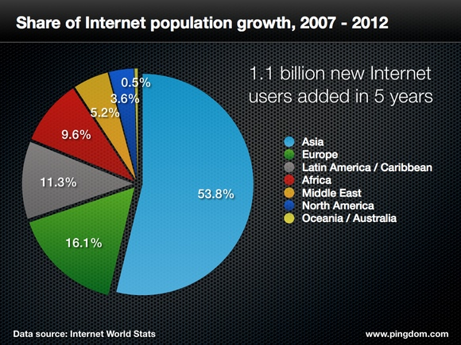

Impact of e-governance

An E-governance impact study by IIM Ahamdabad results indicate that respondents who have used both the manual and computerized systems in the five projects have indicated an overwhelming preference for the computerized system. Their preference is backed with the identification of areas where concrete benefits have accrued to them. In most cases the cost of accessing service has been reduced because the number of trips that needed to be made to the concerned offices has been reduced significantly and the waiting times have come down by nearly fifty percent. Quality of service delivery and quality of governance were also perceived to have improved

Some Impact of e-governance in livestock sector
Today a new paradigm of agricultural development is fast emerging: in both developing and developed countries the overall development of rural areas is expanding in new directions: old ways of delivering important services to citizens are being challenged; and traditional societies are being transformed into knowledge societies all over the world. The report of the “Task Force on India as Knowledge Superpower (GOI, 2001) emphasized the necessity of developing the capacity to generate, absorb, disseminate and protect knowledge and exploit it as a powerful tool to service societal transformation. Information and Communication Technology (ICT) is seen as an important means of achieving such a transformation. When used as a broad tool for providing local farming communities with scientific knowledge, ICT heralds the formation of knowledge societies in the rural areas of the developing world. However, this can only be realized when knowledge and information are effectively harvested for overall agricultural and rural development. The development of precision farming in India emphasizes knowledge-intensity; hence the agricultural paradigm in the developing world will have to be recast to take advantage of knowledge availability to achieve multiple goals: of income, food, jobs. ICT has a significant role to perform in evolving such a paradigm (Meera, et al., 2004).
Agricultural information interacts with and influences agricultural productivity in a variety of ways. It can help inform decisions regarding land, labour, livestock, capital and management. Agricultural productivity can arguably be improved by relevant, reliable and useful information and knowledge. Hence, the creation of agricultural information is now often managed by agricultural organizations that create information systems to disseminate information to farmers so that farmers can make better decisions in order to take advantage of market opportunities and manage continuous changes in their production systems.
Global revolution in information and telecommunication technologies has created an opportunity to remedy the situation and to assist livestock producers, development practitioners, researchers and policy makers to make informed decisions and identify appropriate choices and strategies to cope with and mitigate the effects engendered by constraints in the pastoral livestock sub-sector.

There are three areas in which ICT can contribute to the livestock sector:

- Improved management of data and information
- Improved services including marketing
- Improved learning and capacity development

Integration of technology

In any e-governance livestock projects need to be smartly integrate technologies and modules. For example, the web site www.nadrs.gov.in gives the front-end interface to access to various services on animal disease reporting system. To complete the request the back-end systems are utilised. The integration technology bolts together those non-Internet systems and Web operations and this integration helps to work government offices in real time and provides remarkable opportunities to forecast and track the visitors for 24 x 7

Major ICT Tools for Livestock Management

New ICTs include community radio and television, cellular telephony and SMS services, use of hand held computing devices, digital imaging, the Internet, World Wide Web, e-learning and teleconferencing.

Summary

A study on E-governance impact conducted by IIM Ahamedabad results indicate that respondents who have used both the manual and computerized systems have indicated an overwhelming preference for the computerized system. Using most modern ICT tools a new paradigm of agricultural development can be formulated for overall development of livestock sector. Information and Communication Technology (ICT) is seen as an important means of achieving such a transformation. When used as a broad tool for providing local farming communities with scientific knowledge, ICT heralds the formation of knowledge societies in the rural areas of the developing world.

REFERENCES

Using e-Tools for Good Governance & Administrative Reforms -Dr. P.K. Mohanty, IAS
IMPACT ASSESSMENT STUDY OF E-GOVERNMENT PROJECTS IN INDIA by Center for e-Governance, Indian Institute of Management, Ahmedabad
www.nic.in
Okoro,V.M.O et al: Continental J. Information Technology 5 (1): 22 - 31, 2011
Maru, A. (2006). Potential Contribution from Use of New Information and Communication Technologies (ICTs) For Livestock Production and Services in India.

About the Author

SH Suresh K is working as the District Informatics Officer Principal Scientist with National informatics Centre Thrissur. He has 23 years of experience in e-governance project development and management. One of his projects SAND which is an internet based workflow model for managing the river sand mining and issue of passes bagged first place in Government of Kerala e-governance award 2009 under citizen service category. The project also bagged National e-governance award in 2011 by CSI Nihilent. He nominated as ICT adviser for District Co-operative Bank core banking, University of Health and allied sciences, Kerala Forest Research Institute His expertise includes e-Governance in district administration, Election process, relational data base design and System analysis.

Changing Landscape of Farm Journalism

Dr.T.P.Sethumadhavan

Introduction
We are living in an era characterized by different levels of human disparity and livelihood insecurity. More than 20 crores of people in the country are living below poverty line. Protein malnutrition is an alarming issue; whereas food safety is an imminent issue. The availability and requirement of animal protein sources are more than 200 percent in the country. It is in this context we have to emphasize the importance of farm journalism for augmenting livestock production in the country. Veterinarians have to play a key role in this sector who have to concentrate on farmer friendly research, need based extension programmes and issues which are directly or indirectly affecting the farming community.
Ever since the beginning of planned development in the country, the role of the media in the process of development has been recognized. Information is an important resource input in the process of gradual and orderly change in the tradition bound rural areas. With the launching of the decentralized planning followed by vigorous efforts to empower women and the renewed enthusiasm to spread the light of literacy, the mass media is now in an advantageous position to meet the challenges of rural uplift. In the globalised era we cannot afford to leave our villagers behind resulting in imbalanced growth. This emphasizes the need for evolving a new and effective development communication strategy for rural India.

Farm journalism-
Farmer oriented or community led research findings and user-friendly technologies should be disseminated among the farming community. The media strategies for rural development essentially include the rural press, local radio stations, rural programmes on television, Internet, cable TV, cell phone, e learning, social networking sites and reinforcement through extension agencies, so as to facilitate and reinforce the adoption process through interpersonal and face-to-face communication process.
Major development in the last two decades has been the evolution of special farm pages in the major newspapers including those in Malayalam. Today the press plays an effective role in the dissemination of information on the farm front. This three-decade-old innovation in the area of agricultural development and communication, viz, farm journalism has been producing a tremendous impact on the farming community. It has led to the emergence of a new group of writers namely farm journalists in the history of development journalism.
Several innovative concepts have to be put into practice for reaching millions of farm holdings so as to provide information and confidence to adopt modern technologies. Farmers used to accept them by successfully blending their rich traditional knowledge. Leading Malayalam, Kannada, Tamil, Hindi, Telugu and Bengali dailies used to publish articles of interest to the farmers from their very inception. As far as electronic media is concerned All India Radio, Doordarsan and private TV channels are regularly producing programmes for the farmers. The commencement of the weekly farm feature in Malayalam dailies was a development, which caught the attention of the media and development circles quickly producing a unique impact in the public in general and those concerned with farming in particular. Farm feature pages cover agriculture, animal husbandry, fisheries and allied areas. Nevertheless, publishers need to provide accurate and acceptable information regularly through farm feature pages.
Kerala being a state with high literacy rate in the country, farm publications and newspapers can play a key role in the transfer of appropriate technologies to livestock farmers. Newspapers can focus attention of the farmers towards farm technology and can create interest in them. In the innovation decision process they can be used at all stages, but more useful during the awareness stage. If properly utilized they can also influence farmers in the adoption stage and will reduce the technological gap.

Recent initiatives
The aim of the World society on information held recently in Tunis was to ensure the benefits of the digital revolution reach every part of the country by 2015.. It is based on the principle of an integrated and appropriate use of Internet, cable TV, cell phone, community radio and the vernacular press. The relevance and content should be demand driven and area, culture and time specific. What is important is to ensure that all the initiatives designed to help rural poor in design and development.
Moreover India opened its public sector agriculture research to US private companies enabling the private sector to help identify research areas that have the potential of rapid commercialization with a view to developing viable technologies. Areas of collaboration are expected to include research on sustainable agriculture and marketing systems, use of new information and communication technologies, international food safety and sanitary requirements. The food safety and standards bill 2005, now before a parliamentary standing committee, is the latest in a series of recent initiatives that seeks to diversify agriculture and encourage the vital food processing industry. The proposed legislation will update all existing laws on the subject and usher in food management and safety standards.

Research Highlights
Recent research findings done by the author revealed that Malayalam dailies provided less than one-fourth space of farm feature pages for publishing animal husbandry information. This necessitated more coverage to animal husbandry sector since its contribution to state’s GDP is comparatively higher.
Among different categories of news, even though large animals got more than 50 per cent coverage, buffaloes had been largely neglected. Cows got nearly three-fourth coverage when compared to other large animals. Poultry sector got only one-fourth coverage. Small animals and pet animals occupied 17 per cent and seven per cent space respectively. In general, space provided to different animal husbandry information was obviously less.
Integrated farming got coverage of only two per cent. It is a promising practice towards sustainable agriculture. In view of its ecological and economic significance, media should play a significant role in propagating the concept of integrated farming. Relatively more space was allotted for publishing animal husbandry information related to advance in technology in farm feature pages. Of the five modes of presentation news articles occupied maximum column length in all dailies studied. Frequency of occurrence of news articles, illustrations and question answers were found to be more when compared to other modes of presentation. Articles on cows appeared most frequently. But on buffaloes appeared at an interval of 112 days. More than half the number of dairy articles and nearly one-eighth number of poultry articles published was seasonal. Low seasonality of poultry articles necessitate that more emphasis should be given to maintain seasonality. Reading easiness of dairy articles was found to be good with an average readability as indicated by Fog index of 5.45. More than half the number of dairy articles was found to be relevant. Even though more than two-third scientific messages of dairy articles were accurate; accuracy of general articles was just above 50 per cent. Scientific messages of management articles got maximum accuracy of 73.4 per cent.

Conclusion
Print and electronic media have to revise their media policy in favor of farm sector so that more coverage to animal husbandry information could be given in newspapers and in the electronic media. Animal husbandry feature pages can be published separately on weekly basis.
More coverage of animal husbandry information reported in the four dailies has been in the form of news articles. Scientists and veterinarians should be given a larger share in dailies for reporting their research findings in the form of popular articles.
A regular mechanism should be followed for verifying the accuracy of articles. Experts in the field of agricultural and animal husbandry can be appointed as editors of farm pages.
Malayalam dailies should give maximum importance to common man’s level of readability. Scientists, veterinarians, extension workers, journalists and research institutions should provide timely and relevant animal husbandry related information frequently to the press.
A separate publication and extension division can be started under Directorate of animal husbandry to co-ordinate the coverage of animal husbandry information in the various media. It can be developed as animal husbandry information bureau in future.
Farm Journalism courses should be incorporated along with the curriculum of Veterinary courses. Sufficient training should be imparted to field veterinarians, scientists and students to write popular articles.
Farm feature workshops for improving farm columns should be organized at least once in six months. Editors of respective dailies, Research Institutions, Farm Information Bureau, Animal Husbandry Department, Dairy Development Department, Livestock Development Board, Regional Milk Unions, etc, should take initiation for conducting the workshop.
Content analysis studies on animal husbandry information need to be repeated annually. Moreover, farm journals; Animal husbandry programmes of AIR, Doordarsan and different TV channels should be subjected to detailed content analysis studies to assess the extent of coverage, readability, relevancy, accuracy and reading comprehension.

An Introduction to Intellectual Property Rights

Dr.Jiji. R.S
Associate Professor
Department of Veterinary and Animal Husbandry Extension
College of Veterinary and Animal Sciences, Mannuthy

Before going into the details of the concepts of Intellectual Property and Intellectual Property Rights, it would be necessary to have a glimpse of the evolution of Trade Related aspects of Intellectual Property Rights (TRIPS) Agreement.

Trade Related Aspects of Intellectual Property Rights (TRIPS) Agreement
The United Nations Monetary and Financial Conference, popularly known as the Bretton Woods conference was held at Bretton Woods, USA, in 1944. The conference was held against the backdrop of the great economic depression of 1930s and the further economic meltdown triggered off by the Second World War. Its major objectives were to carve out effective economic crisis management strategies and set a new international monetary order. The forum recommended the formation of three international bodies namely International Monetary Fund (IMF), International Bank for Reconstruction and Development (World Bank) and International Trade Organization out of which the first two bodies were formed in 1944 itself, popularly known as the twins of Bretton Woods conference. But the concept of International Trade Organization was materialized in the form of General Agreement on Tariffs and Trade (GATT) in 1947 at Geneva. The very purpose of GATT was to serve as a multilateral trade organization to facilitate international trade by trimming down the tariff and non-tariff barriers. Since its inception in 1947 till 1986, GATT held seven rounds of negotiations all of which laid emphasis on trade liberalization. But the eighth round of talks, the ‘Uruguay round’ that commenced in 1986 and continued till 1993 was wider in scope as it sought to incorporate several other themes such as agriculture, service sector, Intellectual Property Rights and foreign investment under its ambit. The draft final text of the Uruguay round authored by the GATT Director General Arthur Dunkel was referred as the Dunkel draft. ‘TRIPS’ was one of the major components of the Dunkel Draft. The final version of the draft came to be known as the GATT agreement. On 15 April 1994, the agreement was signed by ministers from most of the 123 participating governments at a meeting in Marrakesh, Morocco. The GATT agreement was redesignated as World Trade Agreement (WTA) and the World Trade Organization (WTO) was established on January 1, 1995 to implement the WTA.TRIPS was an essential component of the World Trade Agreement. Altogether, seventy three articles in seven parts of TRIPS agreement formed the framework of rules and regulations for the implementation of intellectual property rights.
Since India is a founding member of the WTO, we are bound to comply with the provisions of the TRIPS agreement. However, being a leader among the developing countries, India has the moral responsibility to negotiate and intervene in policy matters and issues to protect the genuine interests of the developing world. Awareness of IPR among our science and technology community is absolutely essential not only to make maximum benefit out of the intellectual output but also to address complex techno-legal issues of IPR that may arise in the post WTO scenario.
Intellectual Property (IP)
Intellectual Property can be defined as the property created by the application of human mind. Thus it is a product/creation of human intellect. For example, scientific inventions, computer software, literary and artistic works, trademarks, designs of articles etc come under the category of IP.

Intellectual Property Rights (IPR)
Any movable or immovable property like land, house, vehicles etc. has to be protected from stealing. Similarly the intellectual property has to be guarded from infringement or illegal use by others. The enforcement of rights on the intellectual property is termed as Intellectual property rights and is governed by laws of IPR. The aim is to safeguard the right of ownership of the IPR holder on his/her intellectual property so as to protect and promote innovations.

Forms of IPR
As per TRIPS agreement, there are seven different forms of IPR.These are Patents, Copy rights and related rights, Trade marks, Geographical indications, Industrial designs, Lay out designs of integrated circuits and Protection of undisclosed information or Trade secrets. In the Indian context, Protection of new plant varieties and farmer’s rights is also included in the IP category. The eight different forms of IPR in Indian context are given in figure 1.

Figure 1
Forms of IPR in India

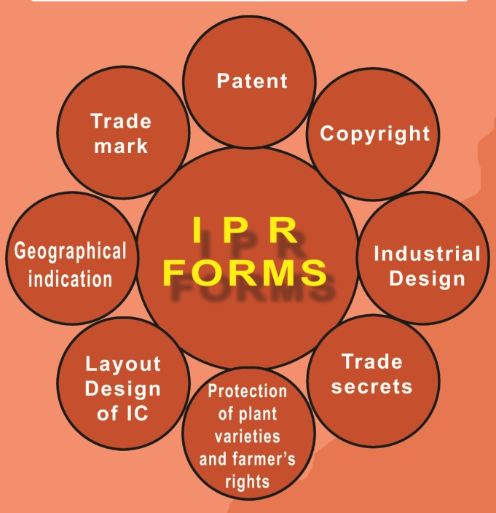

An illustration of the different forms of IPR applicable to a newly developed dairy product (imaginary) is furnished below (fig.2).
Figure 2
Forms of IPR applicable to a new dairy product

Different IP rights differ in the nature of protection offered and fee structure for registration. The table1 below provides a brief account of the same with regard to only those forms of IPs significant in Veterinary and Animal Sciences.

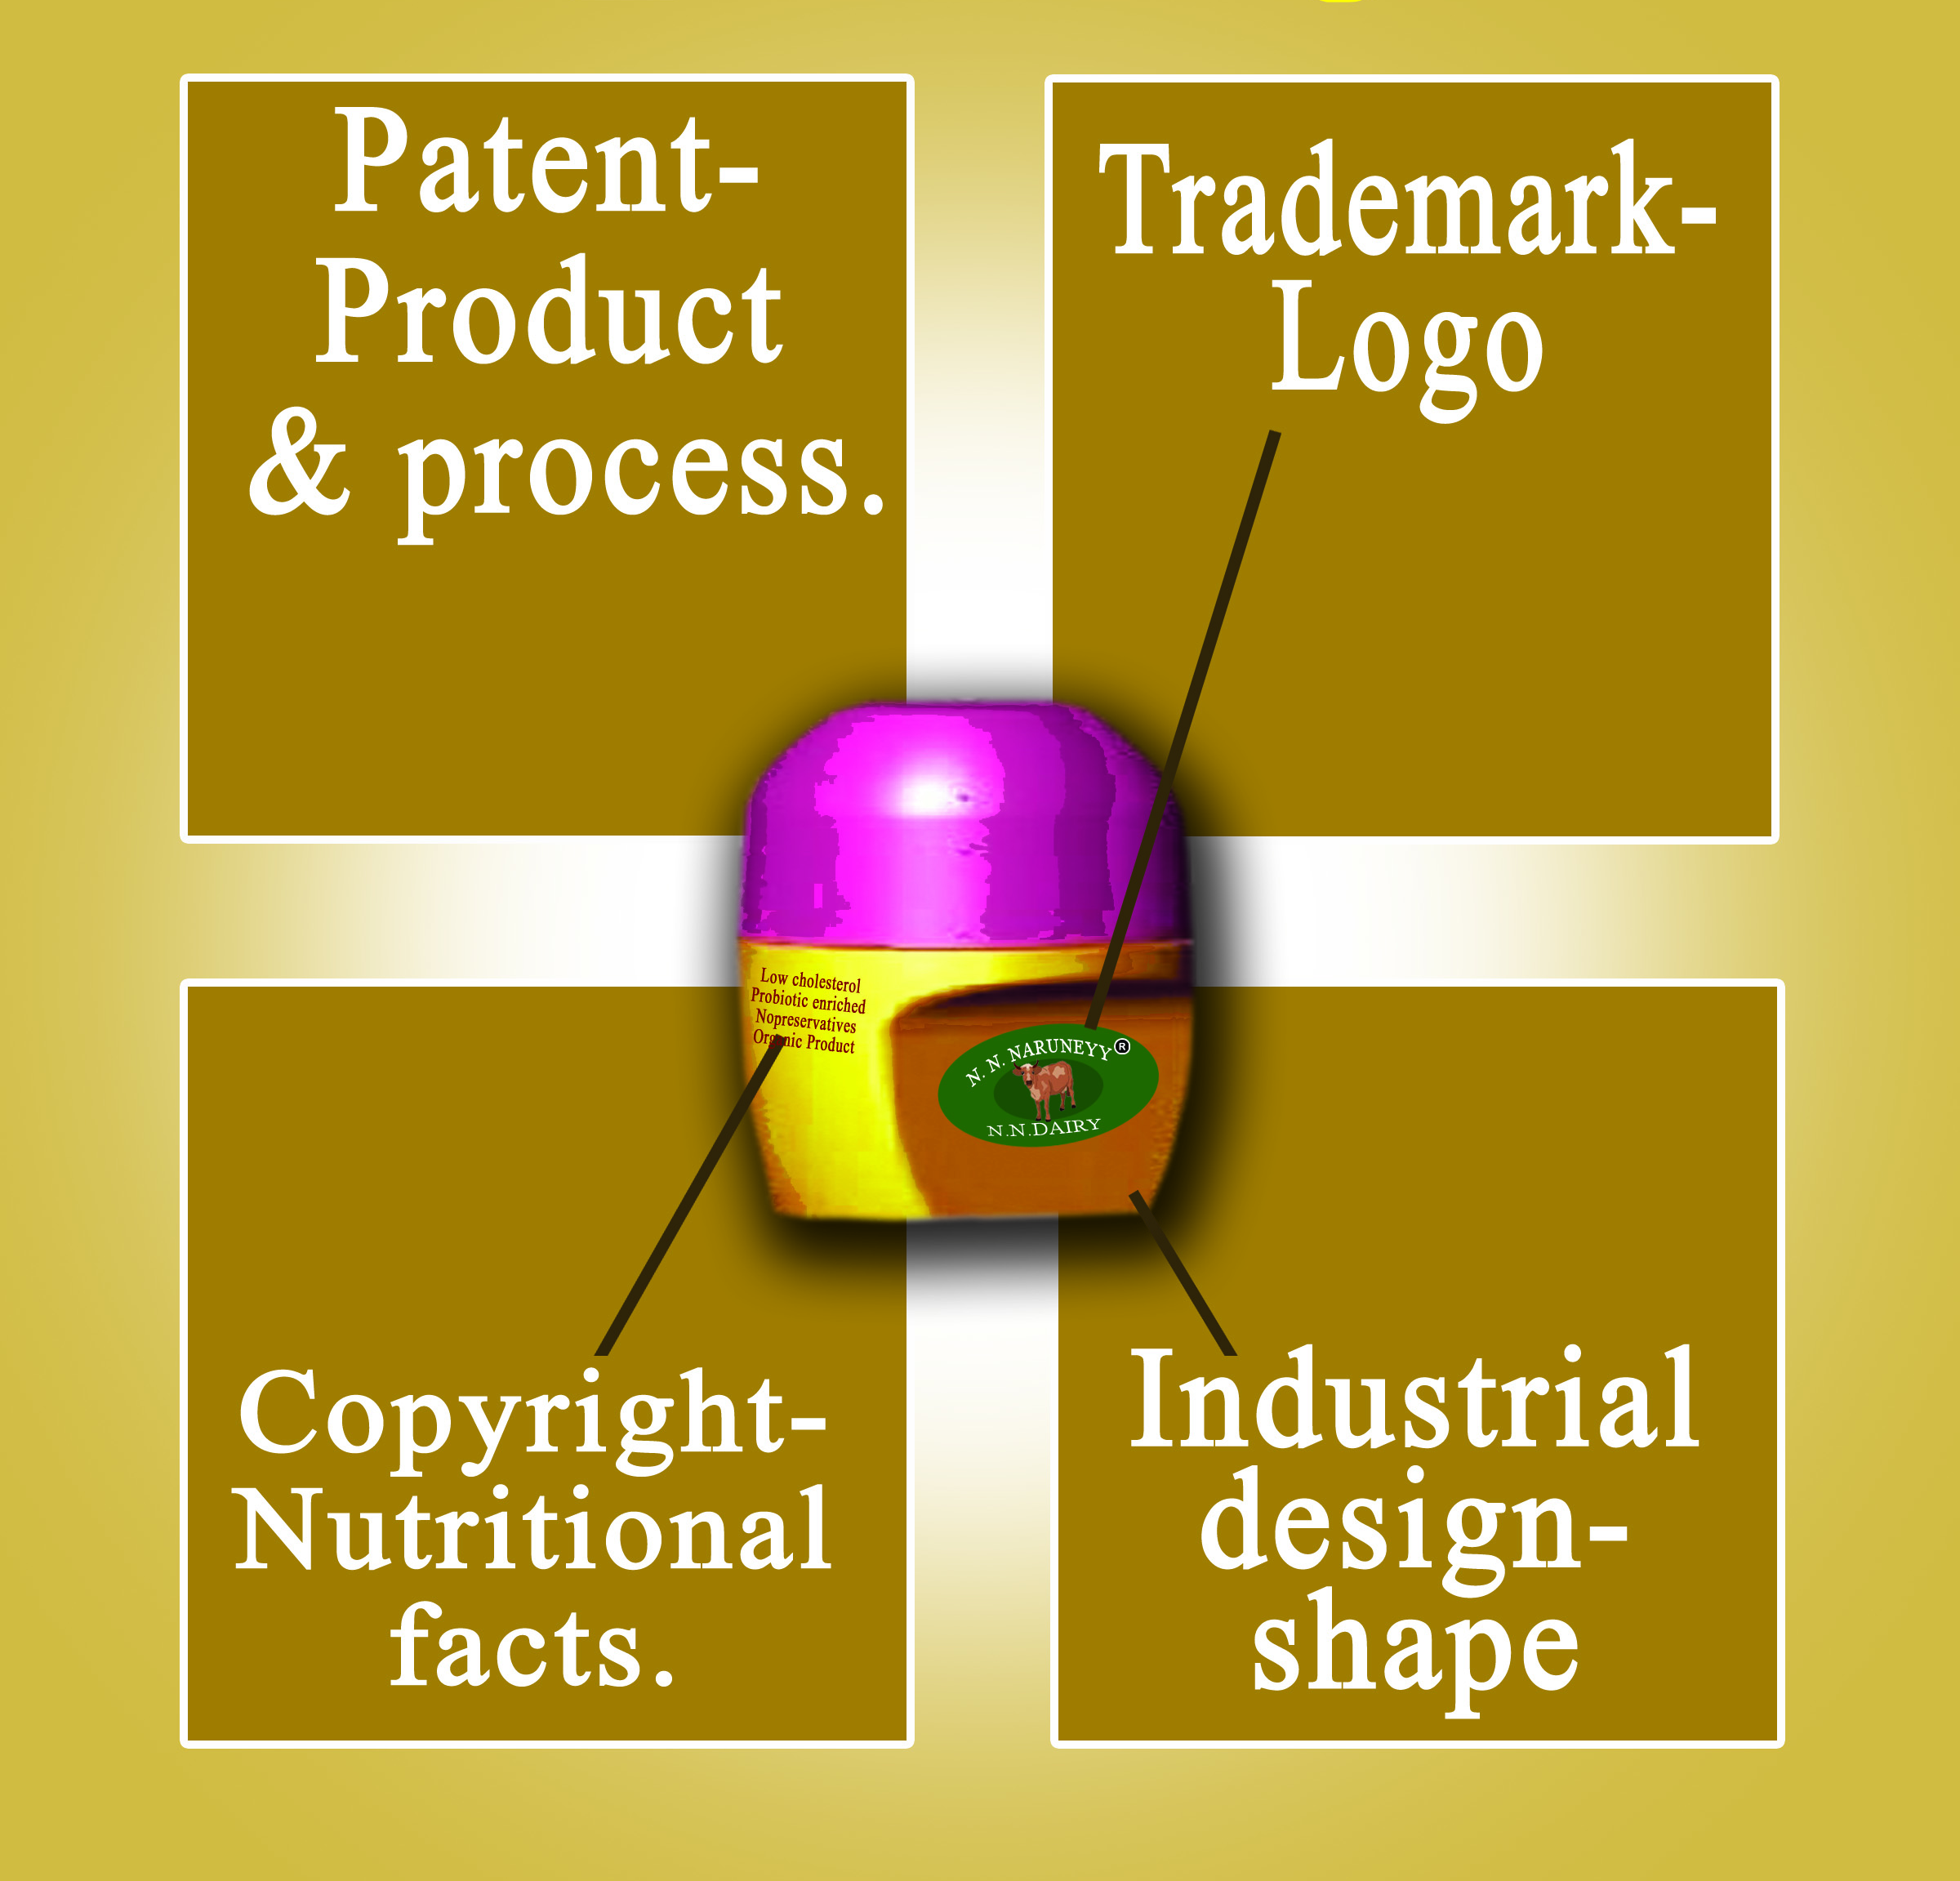

Table 1 An overview of different forms of IPR

PATENTS
Type of protection | Invention in any field of technology (new product or process)  eg:- a new drug, method of its production
Important criteria | - Novelty  - Inventive step  - Industrial applicability  - Patentable subject matter as per law
Duration of protection | 20 years
Fees in Rs.  Filling of patent Application  Early publication  Examination  Renewal Fee 2- to 6 year  7- to 10 year  11 – to 15-year  16-to 20 year | Individual Legal Entity  1000 4000  2500 10000  2500 10000  500 2000  1500 6000  3000 12000  5000 20000
Filing Office for Kerala | The Patent office, Intellectual property office building, G.S.T Road, Guindy, Chennai – 600032  Ph: 044-22502081-84,044-22502080  Fax: 044-2502066  Email: chennai-patent@nic.in, Website: www.ipindia.nic.in
COPYRIGHTS
Type of protection | Literary, musical, dramatic and artistic works,  cinematograph films and sound recordings  eg:- novel, book, painting, sculpture, photographs, computer software
Important criteria | Originality
Duration of protection | Literary works: life time of Author + 60 years  Cinematographic Films, Records, Photographs : 60 yrs  Broadcasting-25 years
Fees in Rs.  Literary, Dramatic, Musical or Artistic work  Cinematographic Film  Sound Recording | 50  600  400
Filing Office for Kerala | Copyright office. B-2W-3  Curzon Road, Barracks, Kasthurba Gandhi Marg,New Delhi – 110001  Ph: 011-23382436, Website: www.copyright.gov.in
TRADEMARKS
Type of protection | Trade name/brand name, logo, company name  eg:- milma, amul, pepsi, rubco etc.
Important criteria | Distinctiveness
Duration of protection | Unlimited  Initially for 10 years (Renewal Every 10 years)
Fees in Rs.  Registration of trademarks of Goods or services in one class  Collective trademark  Renewal fee | 2500  10000  5000
Filing Office for Kerala | Trademarks Registry, IPO building,  G.S.T. Road, Guindy, Chennai – 600032  Ph: 044-22502044  Fax: 044-22502046  Email: tmrchennai@nic.in, Website: www.ipindia.nic.in
INDUSTRIAL DESIGNS
Type of protection | Features of shape, configuration, pattern, or ornamentation applied to an article  eg-shape of car, design of mobile phone, shape of perfume bottle
Important criteria | - Novelty  - Originality  - Distinctiveness
Duration of protection | Initially for 10 years (may be extended further by a period of 5 years)
Fees in Rs.  Registration of Design  Extension Fee | 1000  2000
Filing Office for Kerala | Design wing, IPO building, G.S.T. Road, Guindy,Chennai – 600032  Ph: 044-22502041  Fax: 044-22502042.  Email: tmrchennai@nic.in, Website: www.ipindia.nic.in
GEOGRAPHICAL INDICATIONS
Type of protection | Goods having reputation attributable to the place of origin  eg-Dharwad pedha of Karnataka, Kashmir Pashmina, Malabar pepper, Palakkadan matta rice
Important criteria | Uniqueness
Duration of protection | Unlimited (Renewal After 10 years)
Fees in Rs.  Registration of goods  Registration of an Authorized User  Renewal of an authorized user | 5000  500  1000
Filing Office for Kerala | GI Registry  IPO Building, G.S.T. Road  Guindy, Chennai – 600032  Ph: 044-22502091-93  Fax – 044-22502090  Email: gir-ipo@nic.in, Website : www.ipindia.nic.in
TRADE SECRETS
Type of protection | Secret information containing knowledge of business  eg:- commercial dog breeders keep pedigree information secret, trade secret regarding coca cola formula

In India, Intellectual property is administered by five central ministries. Department of Industrial Policy and Promotion of the Ministry of Commerce and Industry regulates Industrial property which includes Patents, Trademarks, Industrial designs and Geographical indications. The Ministry of Human Resource Development controls the Copyrights realm. The Ministry of Agriculture governs the Protection of Plant Varieties and Farmers’ Rights. Lay out design of integrated circuit falls under the purview of The Ministry of Information Technology which is responsible for the implementation of the Semiconductor IC Layout Designs Act. The implementation of the Biological Diversity Act is the responsibility of the Ministry of Environment and Forests.

Salient characteristics Patents

- Patents are intellectual property rights related to inventions
Patents are intellectual property rights applicable to inventions, whether products or processes in all fields of technology.
eg:- A newly developed drug or the method/process of manufacture of the drug

- Patents are monopoly rights
A patent is the grant for an invention conferred by the government to the inventor /patentee in exchange of complete disclosure of the invention to exclude others from making, using, selling or importing the patented product or process for a limited period of time within the geographical boundaries of the country where the invention is patented.
Patent ensures legal ownership/property rights of the inventor on his/her invention. As in the case of any other movable or immovable property, nobody can use the invention without the permission of the patent owner. The patent owner has the right to license anybody to use the invention on mutually agreed terms. The patent right can also be sold, gifted, assigned or inherited.

- Patents are territorial rights
Patent right is territorial in nature. Patent granted in a particular country is enforceable only in that country and not in any other country. Patent laws also differ from country to country. Certain inventions patentable in one country may not be patentable in another country.
- Patents have a fixed term
Patents are granted only for a limited period of time during which the patentee has exclusive rights on the patented invention. On expiry of this period, the invention enters the public domain and anybody can use it for commercial purposes. The term of patent in India is 20 years from the date of patent application.

- Patents are important in Research and Development (R&D) and Transfer of Technology (TOT)
- Patents act as incentives by recognizing the creativity and innovativeness of inventors and providing material rewards for marketable inventions
- Encourage investment in research as the patent holder can recover the research cost through commercial exploitation of the monopolized goods and services.
- Increased R&D investment eventually leads to scientific and technological advancement.
- Commercialization of scientific inventions contributes to Industrial, social and economic development.
- Enhance the dissemination of information and technologies: - Patenting involves disclosure of the inventions which might otherwise be kept secret. Licensing of patented technologies also results in technology transfer.

- Criteria for patenting
- Novelty: - The invention should have some new characteristic that is totally unknown to the existing body of knowledge or prior art. Prior art means everything that has been published, presented or otherwise disclosed to the public before the date of filing of complete specification.
- Inventive step: - An invention is patentable only if it involves one or more inventive step. Inventive step is a feature of an invention that involves a technical advancement compared to the existing knowledge or having economic significance or both and that makes the invention not obvious to a person skilled in the art.
- Industrial applicability: - The invention should have industrial use. The specific utility has to be indicated in the complete specification.
- Patentability of subject matter as per law:- As per the Indian Patent Act, 1970(amended in 1999,2002 and 2005), certain inventions are not patentable.
Inventions which are not patentable
- An invention which is frivolous or which claims anything obviously contrary to well established laws
eg:- A machine alleged to be giving output without any input
- An invention, the primary or intended use or commercial exploitation of which would be contrary to public order or morality or which causes serious prejudice to human, animal or plant life or health or to the environment
eg:- a method for hacking e-mail accounts, any machine or method for counterfeiting of currency notes, a pesticide that causes serious prejudice to human, animal or plant life or health or to the environment, a method for cloning of humans that is against the social, cultural and legal norms of morality etc.
- The mere discovery of a scientific principle or the formulation of an abstract theory or discovery of any living thing or non-living substance occurring in nature is not an invention
- The mere discovery of a new form of a known substance which does not result in the enhancement of the known efficacy of that substance or the mere discovery of any new property or mere new use for a known substance or of the mere use of a known process, machine or apparatus unless such known process results in a new product or employs at least one new reactant
- A substance obtained by a mere admixture resulting only in the aggregation of the properties of the components thereof or a process for producing such substance
- The mere arrangement or re-arrangement or duplication of known devices each functioning independently of one another in a known way
- A method of agriculture or horticulture
- any process for the medicinal, surgical, curative, prophylactic, diagnostic, therapeutic or other treatment of human beings or any process for a similar treatment of animals to render them free of disease or to increase their economic value or that of their products
- Plants and animals in whole or any part thereof other than micro-organisms but including seeds, varieties and species and essentially biological processes for production or propagation of plants and animals
- A mathematical or business method or a computer programme per se or algorithms
- A literary, dramatic, musical or artistic work or any other aesthetic creation whatsoever including cinematographic works and television productions
- A mere scheme or rule or method of performing mental act or method of playing game
- A presentation of information
- Topography of integrated circuits
- An invention which in effect, is traditional knowledge or which is an aggregation or duplication of known properties of traditionally known component or components.
- Inventions relating to atomic energy and the inventions prejudicial to the interest of security of India.

- Legislation
- Pre- independence era-developments
- The first Indian statute on patent passed in 1856.Granted exclusive privilege to inventors for 14 years.
- Modified and reenacted in 1859.
- Patents and Designs Protection act enacted in 1872
- Inventions and Designs act enacted in 1888
- Indian Patents and Designs Act enacted in 1911
- Post- independence era
The patent system in India is governed by the Patents Act 1970, amended thrice in 1999, 2002 and 2005.

- Patent administration
The patent system in India is administered by the Controller General of Patents, Designs and Trademarks of the National Patent Office. The patent office functions under the control and supervision of the Department of Industrial Policy and Promotion, Ministry of Commerce and Industry, Government of India. It performs the statutory duties related to the grant of patents. The patent offices are located at New Delhi, Kolkata, Mumbai and Chennai. These offices handle the patent applications originating within their respective territorial jurisdictions. The head office is at Kolkata. The office of the Controller General is at Mumbai.

- Patent Facilitating Organizations

Department of Science and Technology (DST), Government of India

Technology Information, Forecasting and Assessment Council (TIFAC)

Patent Facilitation Centre (PFC)

Patent Information Centre at State Capitals

Patent Information Centre, Kerala
Kerala State Council for Science, Technology and Environment (KSCSTE)
Sasthra Bhavan, Pattom, Thiruvananthapuram – 695 004
Tel : 0471-2543701-05
Fax : 0471-2540085
Website- www.patentcentre.kerala.gov.in

Services of PIC, Kerala
- Conduct IPR Awareness Programmes
- Facilitate Patent filing through TIFAC.
- In-house Patent Search Facility.
- A full text searchable database of European and Indian patents in CD-ROM.
- Online search facility.
- Supply of Patent Documents

- International conventions and treaties related to Patents
- Paris convention- 1883
- WIPO- 1967
- Patent cooperation treaty-1978
- Budapest treaty- 1973

- Patenting procedure

- Filing of Patent application
Patent application contains
- Title of the invention
- technical field
- background and description of the invention
- Visual materials like drawings, plans or diagrams to describe the invention.
- “Claims”, that is, information which determines the extent of protection granted
- Abstract
- Publication of patent application
- Published in patent office journal 18 months after the date of filing
- Includes date of application, application no., name and address of the applicant and abstract.
- Not open for public inspection before publication.
- Request for early publication in form no.9 with prescribed fee

- Examination of patent application
  - Request for examination in form no.18 with prescribed fee within 48 months from the date of filing
  - First Examination Report stating the objections/requirements communicated to the applicant within 6 months from the date of publication
  - Amended Complete specification to be submitted within 12 months from the date of FER

- Grant of patent
  - Patent granted after 6 months from the date of publication
  - Certificate of patent is issued, entry made in the e-register of patents and it is notified in the patent office journal and web site.

Tips on active learning

Dr.T.P.Sethumadhavan

- Although this module has been developed based on lectures and power point presentations, experience demonstrates that more active learning takes place through discussions, practice and demonstrations and student to student teaching. Studies have shown that average maximum attention span for attending a presentation is around 20 minutes. This is why we encourage you to keep lectures to a maximum of 30 minutes, allowing more time for active learning.
- Students are often faced with a disconnect between theory and practice, in other words, practical application of theoretical knowledge creates a knowledge gap that may only promote superficial learning. To avoid this disconnect, it is often better to start with case studies first and explain theory after.
- Dale’s Cone of Experience demonstrates the effectiveness of different media on the learning experience, with the least effective (verbal symbols) at the top of the cone and most effective (direct, purposeful experience) at the bottom (see diagram below).

A second illustration that may help to consider the methods used in sharing knowledge is the Learning Pyramid (below) which charts the % retention rates by information delivery:
Lecture = 5%
Reading = 10%
Audiovisual = 20%
Demonstration = 30%
Discussion Group = 50%
Practice by doing = 75%
Teach others/ immediate use of learning = 90%

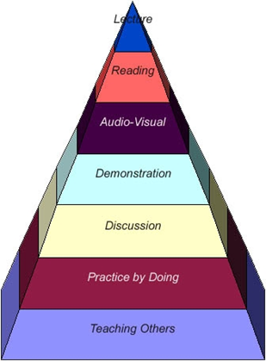
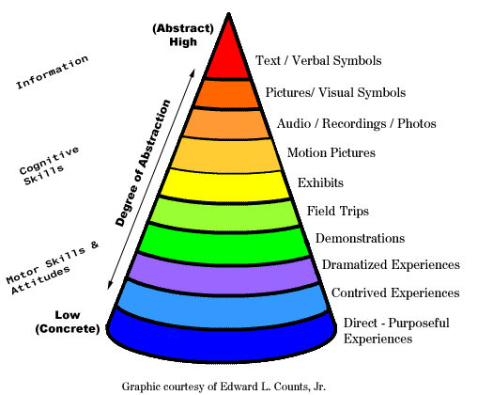
Figure 1. Dale’s cone of experience
Figure 2. The Learning Pyramid

- Whole group discussion
Ask a question of the whole group, and discuss together. Useful for easy questions that can be answered quickly, and at the start of the session to give participants a chance to speak.
- Small group discussion/exercises
Explain an exercise to the whole group, and then ask them to address it in smaller groups. This is usually when you’ve presented something a bit more complex. Asking them to discuss it and answer a question together will help them digest what you’ve told them, and then verbalise the new information for themselves. In a group format, it reduces the pressure on the individual to come up with an answer themselves.
Pairs exercise
Ask participants to talk to their neighbour. This works when you’re confident that everyone has a basic understanding of the topic, so won’t be stuck with only one person to help them. It also works when you have little time for an exercise, as there are less people involved in the conversation. Once you’ve done an exercise with an individual or a pair, you can ask them to join up with another pair, doubling the number of people who share their idea or conclusion.
- Carousel
This technique is an effective way to generate a large number of ideas, alternatives, or responses among a relatively large number of people. Participants have to move around from ‘station to station’, which can be helpful in terms of getting people working together, and boosting energy levels.
- Role playing
Let the participants endorse one of your stakeholder’s roles and experience how they would deal with a given situation.
- Break away sessions-5-6 Students can be divided in to groups and break away sessions can be conducted after prioritizing sub themes.
- Simulation/gaming
New technologies are a fantastic way to learn and experience. Use simulations and games, videos, computers, tablets, etc. Make your audience physically feel and touch the heart of your message.

Examples of Games for students of ecosystems, climate change and disaster risk reduction and systems thinking in general.
Tips on exam questions

- Each CNRD University has its own standards for examinations, however you may consider how to adapt your evaluation system to the learning objectives of this module. You may consider a range of evaluation types from purely knowledge based to practical adoption of learning objectives.
- The type of exam questions may also depend on the number of students and need for very easy grading (i.e. multiple choice) versus examination questions that may better reflect how well learning objectives have been adopted (i.e. exposés, mapping exercise or group work project).
- Examination system may include skill oriented programmeEvaluation of Short term projects
For example:
- Evaluating knowledge >>>> multiple-response, true/false, matching responses, short answers
- Evaluating adoption of risk mapping >>>>> risk mapping exercise, exposé

Field visits

The field visit needs adequate advance preparation, both in terms of logistics as well as preparation of the participants. It is better to omit the field visit altogether than use module time to undertake a touristic outing without clear links to module content. In case community groups or other stakeholders are consulted during the visit, it is important to ensure that they understand the purpose of the visit, including that there may not be any direct follow-up for the visited group.
When planning for the overall training module programme, the organisers need to assess the feasibility of including a field visit, and identity an appropriate objective and context for the visit, such as:
• Demonstrating a practical example of ecosystem-based disaster risk reduction (i.e. visit to a wetland rehabilitation site, with links to flood mitigation).
• Practising a tool, method or approach presented during the module (i.e. conducting community-based risk assessment)
The availability of appropriate field visit sites depends very much on the national and local context. Some general criteria for choosing a field visit site include:
- Relevance of the field visit site for the module content and participants’ previous experience (what can participants gain from the visit?)
- Logistical feasibility (distance, accessibility, security, cost)

Conducting a field visit

- Preparation session
A short session where essential information of the field visit content, aims and logistics is provided to the participants (i.e. the day prior to the visit). If practical work will be undertaken during the visit, then instructions are provided and clarified as appropriate.
- Field visit
The duration of the visit varies depending on the context, but will generally take one full module day. The organisers need to identify an appropriate timing for the module (i.e. last module day, or in the middle of the module).
- Reflection session
Upon completion of the field visit, a feedback and reflection session to analyse the visit, and/or for groups to report back on their results (if practical work was included).

(Excerpts from from IUCN WCC 2012, Conservation Campus learning note)

Learning Communication skills- earlier the better

How to improve communication skills?

To effectively communicate, we must realize that we are all different in the way we perceive the world and use this understanding as a guide to our communication with others. In brief, it’s about transforming personal behavior from impulsive to reflexive level through awareness, observation, understanding and assimilation. As soon as a person realizes that the response to any outer stimuli is not only deeply conditioned but is limited and is mostly prejudiced, he or she becomes conducive to change, taking on new behavioral models, patterns, approaches, and ways. These models and patterns form the basis for new mental actions that ensure better communication in personal and professional activities. These actions become the new unconscious response level, often ensuring better quality of life. (As is the case in the learning of any skill, the stages of competence range from the unconscious incompetence level to unconscious competence).
Such transformations are the objective of Communication Skills Training. The training or practice is done through role-playing games, discussions and exercises under the guidance of a trainer. Both verbal reactions and the playback of video or audio records of nonverbal reactions (e.g. motions, gestures, poses, mimics, and eye contact, voice and speech patterns) are used as the means of feedback. As such, the trainer organizes group work in a way which motivates each participant to consider and accept a wider spectrum of positive daily life models, patterns and communication. It provides an opportunity for each group member to come to his or her own conclusion on his or her past and future behavioral responses.
It is like a jigsaw puzzle, where the pieces fit together only where they belong. The picture can be formed only when everything is in place. If effective communication can be analogized as the image that individual wants to convey, it has to have all the aspects fit in the right way. Starting with listening, conscious effort should be taken to make the right responses verbally or non verbally. The language used in spoken or written forms, the facial expressions, the gestures, the posture ,the appearance, the behavior and other aspects like maintaining the right space and time should all be synchronized..
The good thing is that most of these skills require only deep awareness, observation and understanding of everyday life. The teachers must take the lead. The students must be made aware from an early age. “Communication works for those who work at it”. While not every individual’s movie will be a super hit, we can at least ensure that they are very much appreciated.

The Art of Science Reporting

Dr. B.Sunil
Associate Professor
Department of Veterinary Public Health
College ogf Veterinary and Animal Sciences, Mannuthy

Scientists are trained to research into the varied aspects of science. They have never been trained to write, speak or react to a live audience. But scientists need to communicate their findings to their own community as well as to the public. A scientist could communicate to his peer groups through scientific journals, seminars and symposia, workshops, blogs etc. These reporting’s are purely scientific, which a layman might find it hard to digest. A scientist could also convey his ideas through a journalist. Journalism conveys to us what is new in science. When we say that science is the process of discovery of new facts in this world, this would be incomplete without the last step in this process which is effective communication of the facts. For all the logical reasons, the scientist is the most authoritative person who can explain his findings the best. He has to explain his findings to basically two groups in the society. One is the scientific community, which will try its best to tear his work down, and the other is the general public, whom he has to convince without distorting the scientific facts. Both of these are challenging tasks, but which a scientist should be up to.

Writing Research Articles
Scientists can communicate with fellow scientists through publication of research articles in scientific journals. The journals use a standard format for these articles, in which the author presents the research in an orderly, logical manner. Articles published in scientific journals are peer reviewed.

TITLE
- Make your title short and specific enough to describe the contents of the paper. The title should be appropriate for the intended audience.
- The title usually describes the subject matter of the article: Effect of irradiation on shelf life of ready to cook cutlets"
- Sometimes a title that summarizes the results is more effective: Students Who Smoke Get Lower Grades"

AUTHORS
1. The person who conceived did the work and wrote the paper is generally listed as the first author of a research paper.
2. For published articles, other people who made substantial contributions to the work are also listed as authors. Ask your mentor's permission before including his/her name as co-author.

ABSTRACT
1. An abstract, or summary, is published together with a research article, giving the reader a "preview" of what's to come. Such abstracts may also be published separately in bibliographical sources, such as Biological Abstracts. They allow other scientists to quickly scan the large scientific literature, and decide which articles they want to read in depth. The abstract should be a little less technical than the article itself; you don't want to dissuade your potent ial audience from reading your paper.
2. Your abstract should be one paragraph, of 100-250 words, which summarizes the purpose, methods, results and conclusions of the paper.
3. It is not easy to include all this information in just a few words. Start by writing a summary that includes whatever you think is important, and then gradually prune it down to size by removing unnecessary words, while still retainin g the necessary concepts.
3. Don't use abbreviations or citations in the abstract. It should be able to stand alone without any footnotes.

INTRODUCTION
What question did you ask in your experiment? Why is it interesting? The introduction summarizes the relevant literature so that the reader will understand why you were interested in the question you asked. One to four paragraphs will be sufficient. End with a sentence explaining the specific question you asked in this experiment.

MATERIALS AND METHODS
1. There should be enough information here to allow another scientist to repeat your experiment. This chapter should include the methods you are going to adopt to achieve your stated objectives.
2. If you had a complicated protocol, it may helpful to include a diagram, table or flowchart to explain the methods .
3. If you are using a standard protocol, give the specific reference. If you are modifying the protocol mention the modifications proposed
4. Do not put results in this section. You may, however, include preliminary results that were used to design the main experiment that you are reporting on.
5. Mention relevant ethical considerations. If you used human subjects, did they consent to participate? If you used animals, what welfare measures were taken?. Give a note on why animal experimentation could not be avoided
6. Mention the make and manufacturer of the equipments being used and also the source of reagents and chemicals being used

RESULTS
1. This is where you present your results. You could use graphs and other figures as well as tables if appropriate, but also summarize your main findings in the text.
2. You don't have to include all the data
3. Use appropriate methods of showing data. Don't try to manipulate the data to make it look like you did more than you actually did.

DISCUSSION
1. Highlight the most significant findings, but don't just repeat what you've written in the Results section. How do these results relate to the original question? Do the results support your hypothesis? Are your results consistent with what other investigators have reported? If your results were different from the work of others, try to explain why. Is there another way to interpret your results? What further research would be necessary to answer the questions raised by your results? How do your results fit into the big picture?
2. Conclude with a one-sentence summary, emphasizing why it is relevant.
ACKNOWLEDGMENTS
You can acknowledge those who either helped with the experiments, or made other important contributions, such as discussing the protocol, commenting on the manuscript. You could also use this section to thank your funding agency.

REFERENCES (LITERATURE CITED)
1. In the text, cite the literature in the appropriate places:
Scarlet (1990) thought that the gene was present only in yeast, but it has since been identified in the platypus (Indigo and Mauve, 1994) and wombat (Magenta, et al., 1995).
2. In the References section list citations in alphabetical order.
Indigo, A. C., and Mauve, B. E. 1994. Queer place for qwerty: gene isolation from the platypus. Science 275, 1213-1214.
Magenta, S. T., Sepia, X., and Turquoise, U. 1995. Wombat genetics. In: Widiculous Wombats, Violet, Q., ed. New York: Columbia University Press. p 123-145.
Scarlet, S.L. 1990. Isolation of qwerty gene from S. cerevisae. Journal of Unusual Results 36, 26-31.

Scientific Reporting for the Public
Science reporting process requires honest researchers, informed writers, investigative journalists and savvy, critical bloggers to ensure that public audiences receive accurate big-picture representations of scientific research and discovery. Science backed by empirical evidence and replication is far more interesting and useful in the end than ‘shocking’ preliminary false positive results. So how does a science reporter weigh what to report and what not to report?

What a journalist covering science should look into:
- Evidence is the cornerstone of Science. Some forms of evidence are worth more than others
- A scientist’s authority should command attention based on evidence, not on his belief
- Good science avoids biases
- Uncertainty is a sign of honest science and reveals a need for further research before reaching a conclusion
- Breakthroughs are the result of repeated experimentation
- Balanced reporting does not mean giving equal weight to both sides of an argument. It is giving weight according to the balance of evidence
- New technologies bring benefits with risks. Policy decisions involving science must balance risks and benefits
- Journalists and scientists have similar goals. Both seek truth and want to make it known. They do not want to be misled. Both are adept at verifying information
- Do not sensationalize the scientific report
- Grey areas must be clearly defined and communicated
- Consider public interest when choosing stories to report
- Improve science communication by reporting negative results
- Articles can be laced with anecdotes to make it interesting
Start with a story
Although many researchers are excellent writers, they are bound by a rigid approach to reporting on their research. Scientists often are required to state a hypothesis at the beginning of their report, then restate it at the end and indicate whether the data support the hypothesis. A science journalist is not subject to those limitations. Grab your readers’ interest, then lead them through the research in a way that satisfies their curiosity. You might start off with an anecdote or a story. Begin with something interesting, but leave a few questions unanswered, so that the reader wants to follow along with you all the way to the end. Sometimes that may mean omitting some of the research reported in the article you’re writing about. You might skip whole experiments, or report only part of the results. As long as you’re reporting accurately, there’s no rule saying you have to summarize the entire article you’re discussing.

Avoid scientific jargon
Most of the readers are not scientists, and although scientists do like to read popular accounts of scientific work, they are a secondary audience — and they can always read the original article if they want clarification. Avoid abbreviations at all costs. If you must use a bit of jargon explain what it is all about.

Balance in science reporting
A normal news report can have panelists saying this and that, which could be based on their belief. On the contrary, science reporting has to be always evidence based. A science journalist should be able to understand and assess the truth behind what is claimed by the scientists

The balance of evidence
When the report gets controversial it’s important to weigh up the relative merits of different scientific views before presenting them side by side. Focus on what the balance of evidence demonstrates. The more dramatic the claim, the more cautious you should be.

Choosing your sources:
- Does your expert have a scientific background that is relevant to the area?
- Do they have established credentials? An active research career? What is their reputation among fellow scientists?
- Are there any conflicts of interest or ties to an outside organisation that may unduly influence the results?
How to evaluate a scientific research
Key questions to ask an expert when evaluating research
- How does this study compare with others that have come before?
- How does it add to or contradict existing scientific views?
- Correlation vs. causation – Did A actually cause B, or are A and B connected for reasons we don’t fully understand?
- How large is this study? What was the sample size?
- Was the study well designed? Have the findings been replicated? Will they need to be to gain widespread acceptance?
- Are the results compelling enough to recommend a change in our current behaviour/treatment/ regulations?
- What would be the effect of such changes versus keeping things as they are?
As has been rightly said, “If science is to manage the transition from its older, academic tradition to a new style, while keeping popular assent and the popular image of science as an impartial means of getting at the truth, then the scientific community itself must recognize the importance of maintaining impartial sources of public information.”
FDI in Agriculture-bless or bane?

Dr.T.P.Sethumadhavan
I
In the era of Globalization major structural reforms are taking place in the Agricultural sector. India is on the threshold of Green revolution. Commercialization of Agriculture, Animal husbandry, Dairying, Fisheries and allied sectors are taking place at a faster pace in the country. National Agriculture Policy, agricultural reforms like public private partnerships, market lead extension programmes and agricultural technology management programmes envisage market centered production programmes in agriculture and allied sectors to attain sustainability. As a seqele to GATT and ASEAN agreement, in order to exploit the potentials of market access like export, cutting edge technologies in the areas of value addition, food safety, packaging, quality control, HACCP, etc are needed. Moreover food security issues are emerging over the globe.
Recently Prime Minister Dr.Manmohan Singh emphasized the need for greater attention to local needs by citing an important modern management principle of ‘think global and act local’. Logistics could play a key role in integrating rural and urban divide. A logistics model can provide cost effective access for rural produce to urban markets. Moreover public private partnerships will help to address some of the rural development issues.
In a historical move Government of India on 31st March 2011 brought in a revised policy for foreign direct investment (FDI) in the country. As per the new policy, the norms are extremely relaxed for Foreign Investment, which is expected to create a huge boost in the country’s economy. Major sectors of FDI include Seeds, Plantation, Horticulture, Cultivation of vegetables, Animal husbandry and Fisheries. 100 percent FDI has been allowed in the above sectors including dog breeding. According to the circular by the Department of Industrial Policy and Promotion "Consolidated FDI Policy -- Circular 1 of 2011" while dealing with genetically modified seeds or planting material the company is supposed to comply with safety requirements in accordance with laws enacted under the Environment (Protection) Act on the genetically modified organisms; any import of genetically modified materials, if required, shall be subject to the conditions laid down vide Notifications issued under Foreign Trade (Development and Regulation) Act, 1992; the company shall comply with any other law, regulation or policy governing genetically modified material in force from time to time; undertaking of business activities involving the use of genetically engineered cells and material shall be subject to the receipt of approvals from Genetic Engineering Approval Committee (GEAC) and Review Committee on Genetic Manipulation (RCGM); the Import of materials shall be in accordance with National Seeds Policy.
Circular emphasizes the term “under controlled conditions’’ which covers Cultivation under controlled conditions’ for the categories of floriculture, horticulture, cultivation of vegetables and mushrooms wherein rainfall, temperature, solar radiation, air humidity and culture medium are controlled artificially. Control in these parameters can be made through protected cultivation under green houses, net houses, poly houses or any other improved infrastructure facilities where microclimatic conditions are regulated.
Within Animal husbandry, the term under controlled conditions envisage rearing of animals under intensive farming systems with stall-feeding. Intensive farming system will require climate systems (ventilation, temperature/humidity management), health care and nutrition, herd registering/pedigree recording, use of machinery, waste management systems. Poultry breeding farms and hatcheries where microclimate is controlled through advanced technologies like incubators, ventilation systems etc will also come under this circular. Pisciculture and aquaculture include aquariums and hatcheries where eggs are artificially fertilized and fry are hatched and incubated in an enclosed environment with artificial climate control.
As a part of the new policy, Government of India has brought significant hopes to oversee firms by permitting equity against imported capital goods and machinery and relaxing the norms regarding convertible instruments and downstream investments. It is expected that the farm sectors of the country would now see huge investments by foreign firms. Indian consumers might see better branding, packaging and glamour in the markets of agricultural sector with 100% foreign investment, but this may affect common consumers through risk of price rise and acquisition or closing down of small scale local enterprises. How it will affect the farming community? India being an agrarian country with major focus on small holder livestock production system, whether impact of FDI in Agriculture may affect the common farmer? It is the major challenge before us.

USDA review: Indian egg and poultry production

India has one of the world’s largest and fastest growing poultry industries, ranking third in hen egg production (FAOSTAT) and sixth in broiler meat production (USDA/FAS), according to a report by the USDA’s Agricultural Marketing Service.
Real Gross Domestic Product (GDP) grew 6.4% annually during 2000-2008, making India the second fastest growing major economy in the world (after China). India is expected to overtake China as the world’s most populous country in the coming decades, with middle-class households being the fastest growing segment of the population. About 20% of the population is vegetarian, but with increased incomes and urbanization people prefer to go for non-vegetarian diets.
According to the Ministry of Food Processing Industries, about 70% of poultry is in the organised sector and 30% is in the unorganised sector. Nearly 60-70% of the broiler industry is located in the southern states, as is much of the layer industry. Large integrated operations incorporate all aspects of production: raising grandparent and parent stock, contracting production, compounding feed, and wholesaling. Integration has resulted in lower average costs of production and lower retail prices for poultry meat.
Broiler production grew at an annual percentage growth rate of 8.35% from 2001 (1.25 million metric tons) to 2010 (2.65 million metric tons). Production is projected to grow 2% in 2011 compared to the previous year. Per capita consumption has grown from 1.22 kilograms in 2001 to 2.26 kilograms in 2010, an increase of 185%.
In 2010/2011 (March 2010 to February 2011) India’s egg production is anticipated to reach 61.5 billion eggs, up 68% from 36.6 billion in 2000/2001. Andhra Pradesh and Tamil Nadu are the top fowl egg producing states; West Bengal is the top duck egg producing state.
India’s poultry exports are mainly shell eggs and egg products. Exports of poultry meat are limited by high production costs, inadequate meat processing facilities, and intermittent outbreaks of avian influenza. According to FAOSTAT data, since 2005 India has mostly exported dried eggs. In 2008 India’s top three markets for dried eggs were Germany, Denmark and Indonesia. Angola was the top market for liquid eggs.

Internet expansion will succeed spectacular employment growth in service sectors says McKinsey report
Recent study on ‘the impact of internet on the Indian economy’ by McKinsey reveals that by 2015 internet will contribute 100 Billion US dollars (5 lakh Crore rupees) to India’s GDP from 30 billion US dollars. Moreover by 2015 number of internet users in India will increase from 120 million to 350 million users and the country will move from third to second largest internet user base in the world. By 2015 number of internet users will become 2.6-2.9 Billion; of which 50 percent population will be from developing countries. Globally nearly 20 percent of the user’s access internet on wireless technologies whereas in India it is around 55 percent. Indian internet economy is 1.6-2 times bigger than education, health, hospitality or utility sectors. This will directly create demand for up and down stream industries in the country. Internet economy in India is driven by large companies where individual consumption is only 29 percent; whereas world average is 45 percent.
Absence of low cost and high speed connectivity in small cities and villages, poor rural penetration, increasing cost of ownership& connectivity, poor digital literacy, hurdles in widening and extending application services are the key barriers which affect internet penetration in the country.
Internet will facilitate biggest expansion in agriculture, education, healthcare, public information, entertainment, hospitality & Tourism, retail, telecom, IT, ITeS, Banking, insurance, financial services and industries and will create more employment in the coming years. Since internet facilities can be developed only if entrepreneurship development programmes are strengthened in the country, Entrepreneurship plays a key role in expanding the internet network in the country.
As a sequele to projected development in internet, sectors like education, IT, industries, agriculture, banking and financial services, tourism and export sector will show robust growth in the coming years. So courses catering these areas will have better career potential. Agribusiness, IT, computer science, management programmes, retail, hospitality and tourism management, Banking and financial services, actuary, electronics and communication, cyber security, ITeS, BPO and KPO will be the courses of major attraction in the coming years. Agriculture information, communication, distance and e-learning will witness spectacular growth in the coming years. Education sector will be one of the major beneficiaries through expansion of internet facilities. Online courses from world class universities will reach the doorstep of the users. Universities like Harvard, Stanford and Pennsylvania already started offering free online programmes under Coursera and edex. Digital literacy will help to create awareness on scientific management practices and will help to augment production. Digital literacy training and entrepreneurship models will create the post of skill developers who can act as intermediaries between the web and users. Moreover there is better potential for public private partnership in this sector.

Media and food safety issues

Dr.T.P.Sethumadhavan

Background
A wholesale trader of Delhi says he has been adding chemicals to apples for years to ripen them, despite being told that it causes cancer. As far as he knows, nobody has ever died from eating his produce. So he is unable to understand why the authorities are pestering him, and why he has to pay bribes to keep his business afloat. Doctors are claiming that it causes cancer! An interview with a senior food safety official starkly illustrates just how far India has to go to enforce the regulations properly. Although the authorities have banned the use of calcium carbide as it is carcinogenic, one of the senior officials told that it is not harmful.
From rat poison found in vegetables and Diwali sweets laced with caustic soda- adulteration is rife. A report says; most of the country's milk was watered down or adulterated with products - including fertilizer, bleach and detergent used to thicken the milk and help give it a white, frothy appearance. The report caused an outcry in the world's largest milk producer, where the drink is used for religious rituals and is a source of protein for hundreds of millions of vegetarians. But that is just the tip of the iceberg. The same agency has also found that 13 percent of all food in the world's second-most-populous country failed to meet its standards. Such attitudes explain why India still struggles to make its food fit for consumption.
A world away from the swanky restaurants of New Delhi and Mumbai, awareness about safety only slowly trickles down to the country's millions of small-time vendors. Poverty tempts sellers to add water to products to make them go further. Cheap cooking oil is mixed with expensive oil, tea waste is mixed with new tea, and anything from urea to blotting paper is added to thicken the food sold at festivals. Food safety is often worse in poorer areas where ignorance and the temptation to make a quick buck are greater. Delhi's traders often source their produce from hundreds of kilometers away. In India, where highways are often jammed with traffic, and where storage facilities are primitive, up to 40 percent of perishable food rots before it can be sold. Authorities in Delhi and elsewhere say they are cracking down on safety violations, from fining culprits to conducting surprise raids of food outlets. Raids are especially important during festivals, when bad batches of items such as sweetened milk or flour can send hundreds of people to hospital. It has come to the notice of the authorities that in Kerala synthetic ice creams made of petroleum products are being sold in most parts of the country. Kerala which forms 1.13 percent of the geographic area of the country is a totally literate state. Even though more than 90 percent of the population is non vegetarians, slaughter, meat processing and marketing are taking place through unscientific manner in the state mostly under unorganized sector. But enforcing India's food safety laws is a tough task.
In 2008 in China at least six children died and nearly 300,000 were made ill from drinking powdered milk laced with melamine, an industrial chemical used to give misleadingly high readings in protein tests. But two people were executed in 2009 for their role in the scandal.

Food Safety and Standards Act, 2006

In the era of globalization where trade of products and services are taking place across the globe, food safety is an important concern for the public. Growing issues on food safety compelled the authorities to formulate Food Safety and Standards Act, 2006 which consolidates various acts & orders that have hitherto handled food related issues in various Ministries and Departments. FSSAI has been created for laying down scientific standards for articles of food and to regulate their manufacture, storage, distribution, sale and import to ensure availability of safe and wholesome food for human consumption.
Various central Acts like Prevention of Food Adulteration Act, 1954 , Fruit Products Order , 1955, Meat Food Products Order , 1973,Vegetable Oil Products (Control) Order, 1947,Edible Oils Packaging (Regulation)Order 1988, Solvent Extracted Oil, De- Oiled Meal and Edible Flour (Control) Order, 1967, Milk and Milk Products Order, 1992 etc will be repealed after commencement of FSS Act, 2006.
The Act also aims to establish a single reference point for all matters relating to food safety and standards, by moving from multi- level, multi- departmental control to a single line of command. To this effect, the Act establishes an independent statutory Authority – the Food Safety and Standards Authority of India with head office at Delhi. Food Safety and Standards Authority of India (FSSAI) and the State Food Safety Authorities shall enforce various provisions of the Act. Ministry of Health & Family Welfare, Government of India is the Administrative Ministry for the implementation of FSSAI.

FSSAI has been mandated by the FSS Act, 2006 for performing the following functions:
- Framing of Regulations to lay down the Standards and guidelines in relation to articles of food and specifying appropriate system of enforcing various standards thus notified.
- Laying down mechanisms and guidelines for accreditation of certification bodies engaged in certification of food safety management system for food businesses.
- Laying down procedure and guidelines for accreditation of laboratories and notification of the accredited laboratories.
- To provide scientific advice and technical support to Central Government and State Governments in the matters of framing the policy and rules in areas which have a direct or indirect bearing of food safety and nutrition.
- Collect and collate data regarding food consumption, incidence and prevalence of biological risk, contaminants in food, residues of various, contaminants in foods products, identification of emerging risks and introduction of rapid alert system.
- Creating an information network across the country so that the public, consumers, Grama Panchayats etc receive rapid, reliable and objective information about food safety and issues of concern.
- Provide training programmes for persons who are involved or intend to get involved in food businesses.
- Contribute to the development of international technical standards for food, sanitary and phyto-sanitary standards.
- Promote general awareness about food safety and food standards.

Media being an important stakeholder of the society must take forward the message of Food Safety to each and every corner of the country. This has already been mentioned in the FSSAct2006.

How does news media coverage influence food safety issues?

Food safety information campaigns are more likely to be most effective if the messages are tailored to the needs of a specific audience. Designing effective campaigns involve careful study of the target population and working with them using a community-based participatory research model. Developing health media campaigns will ensure health messages to reach the target audience and, even more importantly, appeal to them. The media is one of the powerful community of people that gives information about facts, the talk about, the latest news and concerns while every people listens to them. For example if the media had told a news about a certain food product that was dangerous in our health the people will not buy that food product anymore to ensure the safety of their family the people listens and believe to the media. Print and electronic media (Telecast and Broadcast media) have a major role in creating awareness on food safety issues among the public. Telecast media has a major role in bringing the news story among the stakeholders.
India's food safety record may actually be much better than it once was, largely because there is a growing awareness of the issue. Indians are becoming more safety conscious thanks to higher literacy rates, clearer food packaging and a modernizing retail sector. An explosion in 24-hour TV news channels in the past decade means coverage of safety scandals can run for days.
Surveys indicate that the American public gets more news about food safety and nutrition from the media than from doctors and dietitians. Nearly half of all stories mentioned the need to reduce dietary fat. Preventing illness through proper diet was a major theme, especially in women's magazines. However, many articles treated individual foods as "magic bullets" rather than components of a balanced diet conducive to good health. The media covered several controversies involving food safety and government nutrition policy. Among the debates that made news were the health effects of manmade additives and contaminants, causes of food borne illnesses, and the efficacy of food labeling regulations. The food industry drew frequent criticism for the dangers of artificial food additives and contaminants. News sources were almost twice as likely to criticize the harmful effects of these substances as to acknowledge their benefits.

Media Influence on Food Safety Practices
According to a survey in the Journal of Food Protection over the past 20 years, there may have been a correlation between media coverage of food safety issues and safe food handling and consumption. Changes in safety of practices over the survey years are consistent with the change in the number of media stories about food safety in the periods between surveys. This finding suggests that increased media attention to food safety issues may raise awareness of food safety hazards and increase vigilance in food handling by consumers. The survey indicates that consumers’ self-reported food safety practices improved after well-publicized, major episodes like the Chinese melamine scandal. Perception of risk might also be influenced by media coverage, while the food safety practices and risk perception trends identified in the food safety surveys were related news articles; there is an intriguing association between these trends and the change in the number of articles. Media coverage of a hazard may increase its perceived risk.
Social media are a potentially rich data source for food borne disease surveillance. They evaluate social media as a food borne disease surveillance system component and discuss novel ways that may facilitate the detection of intentional and unintentional food contamination. 79% of American adults use internet and nearly half of adults (47%), or 59% of internet users use at least one of SNS. Facebook dominated the SNS space in United States of America. 92% of SNS users are on Facebook; 29% use MySpace, 18% used LinkedIn and 13% use Twitter. Almost all the forms of social media give you the option of sharing what you presented on their site with other sites. For example, YouTube videos can be shared via Face book, Twitter, and many other social networking sites.
Examples of common forms of social media that can be used to promote nutrition and food safety include:
- Video-sharing. Example: YouTube and Vimeo
- Presentation-sharing. Example: Slideshare
- Micro blogging or short bursts of information. Example: Twitter
- Photo sharing. Example: Flickr
- Social networking. Example: Facebook
- Professional networks. Example: Linkedin
- Blogs. Example: Wordpress, Blogger, and BlogHer
Both negative and positive food safety information significantly impacted consumers for safer chicken compared to the reportedly less-safe leading brand chicken.

Initiatives
Kerala has unique EEE (Estimation, Education and Enforcement) plan for implementing Food Safety Act in state. Education stage would involve convening a meeting of the health ministers, health secretaries and food safety commissioners of the four south Indian states for ensuring uniform policies in the operation of the law and encouraging them to take penal measures against exporters of hazardous food to Kerala.
As part of the education stage, awareness campaign against junk food at the school level will be initiated under the School Health Programme of the NRHM (National Rural Healthcare Mission).
Similarly, seminars and other awareness camps will be organized at the National, State and District levels to disseminate information through media and will also involve public.
In addition, leaflets, pamphlets, etc. will be printed and distributed through ASHA (Association for Social and Human Awareness) workers, JPHN (Junior Public Health Nurse) / JHI (Junior Health Inspector) of the NRHM. Moreover department is also exploring the possibility of printing messages on the hazards of foods on the rear side of state lottery tickets which will reach around 75 lakh people every week. To encourage inflow of information from all stakeholders regarding adulterated / unsafe food, the FSSAI has proposed to introduce a scheme of rewards for informants. Total literacy of the state facilitates the authorities to implement strategic awareness programmes using print and electronic media.
National Institute of Nutrition (NIN), Hyderabad, has undertaken two separate research projects on food labeling—Consumer knowledge, and practices of using labels in India. Project on consumer knowledge and practices would be undertaken in Delhi and Hyderabad. Consumer studies by way of survey would be an important component of this project, whereby consumers would be questioned outside supermarket stores. They would be asked questions on food labels, like, whether they were easy to comprehend, what they usually looked out for in the labels, which aspect they did not understand and expectations from a label. The second important project is to create mass awareness among people. NIN intends to start the project at school and college level as it believes that educational institutes are the fastest medium of spreading awareness.

Outcome
The USDA Food Safety Inspection Service's Pathogen Reduction and HACCP regulations have increased quality standards in the meat and poultry market. With high regulations both at the Central and State levels, the Dairy, Meat, Poultry, Seafood & Egg has to adhere to strict internal quality standards, without any compromises. Food Safety products ensure that all internal quality standards are adhered at both the Central and State levels for fluid milk, cheese, butter, cultured products, ice-cream, UHT processing and dry ingredients. With an increase in product recalls and consumer awareness, protecting the company's brand name and staying competitive in the marketplace has become vital.
The next time you visit your favorite baking house or any other small-time food seller, don't be surprised to see the vendors sport aprons and hand gloves. According to the new Food Safety Act, hawkers, food vendors and temporary stall owners must follow minimum standards of food safety or pay a maximum fine of Rs one lakh. With the implementation of the new rules, even vegetable or fruit sellers who use chemicals to ripen their products will be liable for punishment. Safe handling of meat, chicken and eggs through washing hands or prep surfaces after touching or cutting raw meat has increased since 1988. Women report safer food handling and eating more than men. Those in the oldest (65 and older) and youngest (18 to 29 years old) age groups were most likely to eat risky foods. Centre for Science and Environment (CSE) organized South Asian Media Briefing Workshop in New Delhi to share its understanding and knowledge of a range of issues under the broader subject of food safety and environmental toxins - pesticides, junk food, contaminants, drugs of daily use, industrial contaminants, industrial liability, regulations and regulatory capacity.

WHO says
Unsafe food causes many acute and life-long diseases, ranging from diarrhoea to various forms of cancer. WHO estimates that food borne and waterborne diarrhoea together kill about 2.2 million people annually, 1.9 million of them are children. Food borne diseases and threats to food safety constitute a growing public health problem and whose mission is to assist Member States to strengthen their programmes for improving the safety of food all the way from production to final consumption. Food borne diseases takes a major toll on health. Millions of people fall ill and many die as a result of eating unsafe food. Deeply concerned by this, a resolution was adopted by WHO and its Member States to recognize food safety as an essential public health function, and to develop a Global Media Strategy for reducing the burden of food borne diseases.

Analysis of communication linkage from livestock research specialists to livestock owners in Iran

A Rezvanfar, M Akbary and A H Hemmatyar

Department of Agricultural Extension and Education, University College of Agriculture and Natural Resources, Faculty of Agricultural Economics and Development, University of Tehran-Karaj

arezvan@ut.ac.ir

Abstract
This study analyses communication linkage between livestock research specialists and livestock owners in Iran. The study employed survey method as a research approach. Population under study were all research staff (203 people) who were dealing with research activities in the livestock husbandry and veterinary areas under Agriculture and livestock research Centers under Ministry of Jihad-Keshavarsi. To study, a sample of 70 livestock and veterinary research specialists were selected using “Proportional Random Sampling” method. Data were collected using a structured questionnaire. The criteria like frequency, percentage, mean, mode and standard deviation were calculated. Factor analysis model was used to reduce and classify communication methods and media used for dissemination of information, knowledge and skills regarding to livestock and veterinary technologies

According to factor analysis methods and media for communication from livestock research specialists to livestock owners consisting visiting in the office, visits in the field, radio broadcasting, seminars and workshops, training courses, television broadcasting, exhibition, field demonstration and extensional and educational bulletins are ranked less to high importance and priority, respectively.

Keywords: communication linkage, livestock research, livestock owner, communication methods
Introduction
Livestock production is the backbone of Iran’s agricultural economy. More than 36% of value added of agricultural sector comes from the livestock production sector which also employs about 70% of the labor force in agriculture (Management and Programming Organization 2002). The application of livestock farming technologies remains important for any livestock farmer, as disease, high mortality, low income and low capacity are major constraints on livestock production in Iran (Management and Programming Organization 2003). This leads to the major problem that livestock farmers produce below capacity in compare with livestock farmers who live in developed countries. This happens while established public technology generation and dissemination organizations in national/state levels are generating and transferring information, knowledge and skills among livestock farmers.
The usage of veterinary services and other dairy farming technologies remains important for any livestock farmer, as disease, high mortality and low capacity are major constraints on livestock production in Iran (Management and Programming Organization 2003). For instance beef and veal output per head of cattle in North America is 280-300 kg whereas yields in Asia and Iran are about half at 120-150 kg, respectively (USDA 1999). This leads to the major problem that livestock farmers produce below capacity in Iran and Asia.
Extension and education provides an important linkage between farmers and researchers, and farmers have come to value the services they receive from Extension (Ekanem et al 2001). The livestock extension services have been traditionally funded, managed and delivered by the public sector in Iran. The Ministry of Jihad-e-Keshavarsy through its veterinary and livestock extension departments carries out most of the veterinary and livestock extension program (Rezvanfar and Mandape 2000). The role of the veterinary and livestock extension service is to advise livestock farmers on various aspects of veterinary and livestock production, supply inputs such as chemicals, forage and concentrates, and provide services like livestock and stable sprays against ticks and diseases (Ministry of Jihad-e-keshavarsy 2002).
Based on the traditional linear approach for veterinary and livestock extension in Iran, these programs have met with limited success and were abandoned one after another. Indeed, to attain sustainable agricultural and livestock production while conserving the resource base, the Government of Iran developed the capacity of the national agriculture and livestock research system (Taeb and Keshavarz 1999; Gharehyazi et al 2003). In other words, integrating science and appropriate technologies in the livestock sector based on a knowledge management approach and requirements of a knowledge economy. This is a considerable strategy for dairy farming development.
Agriculture and livestock research systems and associate actors as enabling institutions in agricultural development framework (Pretty 1995), are main sources of generation and development of technologies and knowledge in agricultural sector, as the linchpins of agricultural development (Dalrymple 2000). The Ministry of Jihadi-e-keshavarzi in Iran has responded to the challenge by initiating capabilities to introduce training courses and transfer of technology in the regional agriculture and livestock research centers.

Theoretical framework
According to theory of “communication for development”, the role of communication methods and media and information sources are very important in diffusion of innovation, but methods, media and sources needed to be effective to ensure impact (Melkot 1998).
If information is to be used and empowering, it must be disseminated in a manner that best facilitates its reception. However, information is delivered in a multitude of manners and the challenge is to determine which method is most appropriate to the audience attempting to be reached. Studies clearly show that clientele preferences exist and may be quite different depending upon the audience being served. Considering the great variability among groups and indicated personal preferences, it is likely that no single delivery method is suitable for everyone (Richardson 1995). Previous studies have noted that farmers’ preferences for informational delivery methods depend on a variety of demographic characteristics such as age, income, formal training courses, and farm size (Iddings and Apps 1992).
Landowners living in the urban/rural interface have diverse interests and unique concerns (Creighton et al 2002). The abundance of methods and media for disseminating information creates a need for extension and education to know the types of technology its audience owns and/or regularly uses (Orr 2003). Knowing the audience will assist the source in disseminating information in a method that is both well received and used.

The challenge arises in how best to disseminate information to target populations. Information dissemination is a core principle of the Oklahoma Cooperative Extension Service and they must therefore determine who its audience is and how to most effectively target and disseminate information to that audience (Orr 2003). Not only does the Cooperative Extension Service strive to meet the needs of large production farms, but also it seeks to fulfill the needs of small-farm landowners, non-traditional producers, and homeowners (Polson and Gastier 2001). Subsequently, because of a much broader audience today, extension must seek the most effective means of reaching individuals based on their preferences for receiving information.
Livestock owners take decisions in their day-to-day lives that may affect the productivity of their livestock system. In talking decisions, however, livestock owners are greatly aided by the amount of information, knowledge and technologies available to them about their felt needs. So that, extension, training and dissemination of information to livestock owners will be a critical input for the modernizing of farm production and home management in rural areas (World Bank 1992).
Rapid growth of communications in agriculture in the 1950s led to increasingly competitive media environment and created strong demand for marketing and demographic research to target farm and consumer audiences (Evans and Salcedo 1974). Agricultural communication research has made contributions to many disciplines and offers a variety of practical applications. According to Ford and Babb (1989) information about farmers’ communication has proved to be of critical importance to agribusiness and other organizations to reach client audiences in a highly competitive market office.
Agriculture and Livestock Research Centers in Iran involved in introducing and transferring new practices and technologies amongst livestock owners. However, various communication methods and media like extensional and educational bulletins, field demonstration, field and office visits, radio, television, training courses, and trip visits employed for dissemination of knowledge and information regarding to dairy farming technologies and practices among livestock owners (Ministry of Jihad-e Keshavarsi 2002).
Information in an enterprise is important for the production process, the economy of products, technical quality, production capacity, and the market and market related needs, such as competitive intelligence. Mudukuti and Miller (2002) suggested that in the information age, dissemination of information and applying this information in the process of agricultural and livestock production will play a significant role in development of farm families. Similarly Sligo and Jameson (2000) in their experiences have also stressed that livestock owners must be given training on latest technological skills and maximize production. The application of diffusion theory to the current study suggests that researchers are active information disseminators across a variety of communication methods and media according to that accessibility.

Purpose of the study
According to the importance of communication methods and media in the process of information dissemination and transfer of technology in the livestock production this paper will attempt to investigate communication linkage from livestock research specialists to livestock owners in Iran. The specific objectives of this study were:
1- Methods and media used by livestock research specialists for dissemination of information and skills about livestock and veterinary managerial technologies.
2- Analysis of communication level between livestock research specialists and livestock owners.
3- Comparing of the two groups of livestock research specialists related to level of communication linkage with livestock owners.
4- Measuring and explaining importance and priority of various communication methods and media were used by livestock research specialists for dissemination of information.

Materials and methods
This study analyses communication linkage from livestock research specialists to livestock owners in Iran. The study was carried out in 2005 through a survey research design for data collection. The statistical population includes all 203 livestock research specialists who dealing with research activities about livestock affairs in the governmental Agriculture and Livestock Research Centers. A sample of 70 livestock research specialists (25 veterinary science specialists and 45 livestock science specialists) with at least 3 years of experience in research activities was selected by using of “proportional random sampling” method. The sample size was determined by using Cochran's formula (Kerlinger 1996). Data were collected by filling out the questionnaires that had been tested previously. In order to determine the validity of the questionnaire, the content was tested. This was done by using a panel of specialists and a multi-step correction and review process.
Earlier, a pilot study was conducted in Tehran, West Azarbayjan, East Azarbayjan and Fars provinces using 30 people. The aim was to test and improve the questionnaire. Cronbach's alpha computed to measure reliability of the developed “communication linkage” index was 0.78 which showed that index has high reliability (Kerlinger 1996). Data analysis was carried out in two sections, consisting data description and data inferential analysis. Descriptive statistics such as frequencies, percentage, cumulative percentage, mode and median were used in the first section. Compartmental analyses such as t-Test and Loan Test and factor analysis were used in the inferential analysis section.
Communication linkage between livestock research specialists was explained according to methods or media used by livestock research specialists for dissemination of information and skills about livestock and veterinary managerial technologies to livestock owners. Amount of communication about livestock and veterinary technologies from livestock research specialists to livestock owners was measured by subjecting each method or media to a four point continuum from none, low, medium and high having scores 0, 1, 2, and 3, respectively. For determining communication level from livestock research specialists to livestock owners the scores obtained by respondents for their communication with every livestock owner were added together.
T-Test was also used for comparing two groups of livestock research specialists related to level of communication linkage with livestock owners. Also, factor analysis used for measuring and explaining the importance and priority of various communication methods and media were used by livestock research specialists for dissemination of information, knowledge and skills regarding to livestock and veterinary technologies towards livestock owners.

Findings and discussion

Frequency distribution of livestock research specialists regarding communication linkages with livestock owners

The frequency distribution of livestock research specialists about communication with livestock owners showed in Table 1.

Table 1. Frequency distribution of livestock research specialists regarding to communication with livestock owners
Component | not |  | low |  | medium |  | high |  | Mode
Component | frequency | percent | frequency | percent | frequency | percent | frequency | percent | Mode
Visits in the field | 14 | 20 | 18 | 25.7 | 22 | 31.4 | 16 | 22.9 | medium
Visiting in the specialists office | 11 | 15.7 | 33 | 47.1 | 21 | 30 | 5 | 7.1 | Low
Extensional and educational bulletins | 32 | 45.7 | 14 | 20 | 22 | 31.4 | 2 | 2.9 | Not
Seminars and Workshops | 34 | 48.6 | 21 | 30 | 14 | 20 | 1 | 1.4 | Not
Training courses | 51 | 72.9 | 9 | 12.9 | 7 | 10 | 3 | 4.3 | Not
Exhibition | 50 | 71.4 | 15 | 21.4 | 5 | 7.1 | 0 | 0 | Not
Movie showing | 61 | 87.1 | 5 | 7.1 | 4 | 5.7 | 0 | 0 | Not
Field demonstration | 60 | 85.7 | 5 | 7.1 | 3 | 4.3 | 2 | 2.9 | Not
Television broadcasting | 50 | 71.4 | 13 | 18.6 | 6 | 18.6 | 1 | 1.4 | Not
Radio broadcasting | 51 | 72.9 | 12 | 17.1 | 5 | 7.1 | 2 | 2.9 | Not

It is explained according to methods or media used by livestock research specialists for dissemination of information and skills about livestock and veterinary managerial technologies towards livestock owners.

Visits in the field

Results of field studies show that 53.4 percent of the livestock research specialists communicated with livestock owners "moderately" and "highly" and 20 percent of them have never experienced this method of communication.

Visiting in the specialists office

Research results revealed that majority of the livestock research specialists, 47.1 percent, have communicated with livestock owners at a low level and 15.7 percent of them have never experienced this method. 37.1 percent of livestock research specialists have implemented this method moderately and highly.

Extensional and educational bulletins

Findings showed that most of livestock research specialists (45.7 percent) have not used extensional and educational bulletins for communicating with livestock owners, and only 2.9 percent of them have used it highly.

Seminars and workshops
It was found that 48.6 percent of livestock research specialists have not communicated with livestock owners through seminars and workshops and just 1.4 percent of them have implemented these methods highly.

Training courses
Study analysis showed that 72.9 percent of livestock research specialists have never taken advantages of educating livestock owners through training courses. While only 4.3 percent of them have used highly this method for communication with livestock owners.

Exhibition
Analysis of the findings showed that 71.4 percent of livestock research specialists have never communicated with livestock owners through method of exhibition. However, 28.5 percent of them have implemented this method to some extend (low to moderate) for communication with livestock owners.

Movie showing
Results of the study showed that 87.1 percent of livestock research specialists have never used this method and media for communication with livestock owners.
About 13 percent of them used movie showing for communication low to high, respectively.

Field demonstration
Results of the study showed that 85.7 percent of livestock research specialists told that they have never experienced this method for communication with livestock owners. Only 2.9 percent of them have used this method highly.

Television broadcasting
Results of the study showed that 71.4 percent of livestock research specialists have never used this media for communication with livestock owners. Only 1.4 percent of them have used this media highly.

Radio broadcasting
Results of the study showed that 72.9 percent of livestock research specialists have never implemented radio broadcasting for communication with livestock owners. and Only 2.9 percent of them have communicated with livestock owners through radio broadcasting for communication with livestock owners.

Frequency distribution of livestock research specialists according to level of communication with livestock owners

Analysis of communication level between livestock research specialists and livestock owners implies that majority of livestock research specialists (80 percent) had a weak level of communication with livestock owners. None of livestock research specialists had a strong communication with livestock owners (Table 2).

Table 2. Frequency distribution of livestock research specialists according to level of communication with livestock owners
Level of communication | Frequency | Percent | Cumulative percent
Low | 56 | 80 | 80
Medium | 14 | 20 | 100
High | 0 | 0 | 100
Total | 70 | 100

These results are in consistence with Ford and Bob 1989, Rezvanfar and Mandape (2000), Sligo and Jameson (2000) and Mudukuti and Miller (2002).

Results of compartment analysis: t-Test

The results of t-Test for comparing of the researchers related to level of communication linkage with livestock owners is given in table 3.

Table 3. The t-Test for comparing of the researchers related to level of communication linkage with livestock owners
Variable | Leven test |  | t- test | Groups
Variable | F | variance | t- test | Group 1 | Group 2
Communication linkage | .25^{ns} | equal | .351^{ns} | Livestock science researchers | Veterinary science researchers
Communication linkage | .25^{ns} | different | .351^{ns} | Livestock science researchers | Veterinary science researchers

According to the results it can be cited that there was not any significant difference related to level of communication linkage with livestock owners. Loan test was also used to define variance equality of different variables in the both livestock science researchers and veterinary science researchers, and results revealed that variant distribution of variables is the same in two groups.

Factor analysis results

In this part, factor analysis used for measuring and explaining importance and priority of various communication methods and media were used by researchers for dissemination of information, knowledge and skills regarding to livestock and veterinary technologies towards livestock owners. Data in Table 4 show that relatively, extensional and educational bulletins, field demonstration and exhibition have ranked first, second and third according to importance and use for dissemination of information, knowledge and skills regarding to livestock and veterinary technologies towards livestock owners.

Table 4. Factor analysis for measuring importance and priority of the various communication methods and media were used by researchers
Row | Method and media | Factor loading | Rank of factor loading
1 | Visits in the field | -0.171 | 9
2 | Visiting in the specialists office | 0.288 | 10
3 | Extensional and educational bulletins | 0.644 | 1
4 | Seminars and workshops | 0.443 | 7
5 | Training courses | 0.472 | 6
6 | Exhibition | 0.547 | 3
7 | Movie showing | 0.532 | 4
8 | Field demonstration | 0.601 | 2
9 | Television broadcasting | 0.594 | 5
10 | Radio broadcasting | 0.367 | 8

Visiting livestock owners in working office, visiting livestock owners on fields and communicating through radio broadcasting were ranked tenth, ninth and eight, respectively. These results are in consistence with findings of Richardson 1995, Rezvanfar and Mandape (2000), Sligo and Jameson (2000) and Orr (2003).

Conclusion and recommendations
- Analysis of communication level between livestock research specialists and livestock owners implies that majority of livestock research specialists (80 percent) had a weak level of communication to livestock owners. None of livestock research specialists had a strong communication with livestock owners. These results, implies that there is not an assembled accomplishing mechanism for livestock research specialists to communicate with livestock owners in respect of dissemination of livestock and veterinary managerial technologies . According to important role of communication between researchers and livestock owners regarding to dissemination and transferring the most recent research findings, it is highly recommended to establishing a mechanism for generating a formal and planned methods and media consisting field visits, visiting livestock owners in office, extensional and educational bulletins, seminars and workshops, training courses, exhibitions, movie showing, field demonstrations, television and radio broadcasting programs for enhancing communication linkages between livestock research specialists and livestock owners.
- According to factor analysis methods and media for communication from livestock research specialists to livestock owners consisting visiting in the office, visits in the field, radio broadcasting, seminars and workshops, training courses, television broadcasting, exhibition, field demonstration and extensional and educational bulletins are ranked less to high importance and priority, respectively. While, livestock owners in Iran are basically illiterates and lack basic information infrastructures so, in order to improve communication from livestock research specialists to livestock owners, it is recommended that besides focusing on printed materials and mass methods, individual methods including visiting livestock owners on farm and working office should be used for communicating to livestock owners.

- In the information age, basic infrastructures such as computers, access to the internet and other suitable communication technology like radio and internet together and linking rural radio to new ICTs are needed in rural communities in order to transfer the latest information relate to livestock and veterinary managerial technologies amongst livestock owners. However, issues of traditional literacy and digital literacy would need to be resolved.

Innovative Knowledge Transfer Equipments & Tools for effective transfer of Animal husbandry technology

Dr.T.S. Rajeev,
Asst. Professor, Dept of Vety & AH Extension, COVAS, Mannuthy

1. COMBACCS (Cell Phone Operated Mobile audio Communication & Conferencing system)

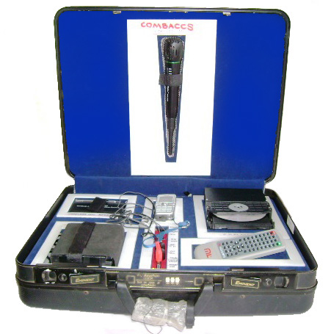
It is a cell phone /mobile phone based audio interaction mechanism. The farmers / group members shall have direct interaction through mobile phone with an expert at any time. This method is just as the mobile phone dialogue between two individuals, in which on one side it can be heard through a loudspeaker to a larger number of audience group and the whole group can interact at same time . It needs a mobile connection, and an active sim card between the expert and the group. The cell phone usage is more common and widely spread in Kerala, which can be effectively utilized for technology transfer self help groups and to groups.

2. ASLICS (Automated Self Learning & Interactive Communication System)
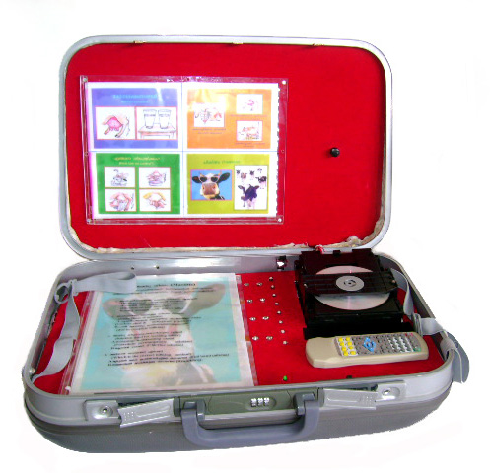
The learning activity in any case will be intense, if the mode is self learning. This principle is used in this box. The ASLICS box for knowledge transfer creating enthusiasm and surprise. Four questions with two answers each are projected through backlighting. Answer is given as multiple choice of A & B. Corresponding answer buttons are also provided. The respondent has to answer four questions as A or B by pressing the relevant button and the last button pressing leads to video non projected slide by slide description of that particular topic support-ed by an audio announcement. The user gets a comprehensive idea of a particular subject where in he/she actively involves in the learning process. It is operated in 6 hours battery back up and hence useful at places with out electricity.

3. VAKTHRAM (Visual Assistant and Knowledge Transferring Automated Mechanism)
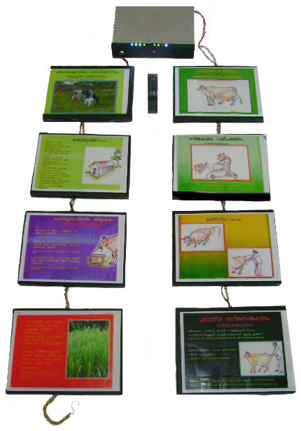
It is a teaching aid for the master trainers of Women Self Help Groups. A topic which has to be discussed in the meeting will be divided into eight sub topics . Each sub topic made to illuminated slides and controlled by a remote,so that teacher can illuminate one by one and explain simultaneously. At the end of session each slide will automatically repeat illumination and will lead to full projection.
This instrument can be hanged in the wall any where and is so light that it fit into any common mans house wall. It has 4 hrs battery backup for charging for two hours

4. SARANA (Self Learning Aid and Ready-Reckoner in Animal Husbandry Activities)

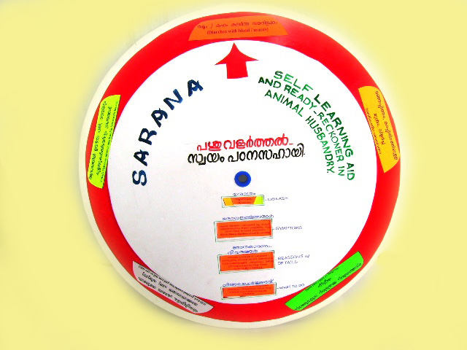
It is a Ready Reckoner type visual aid containing information on Animal Husbandry. Pointing the arrow to the required information in the outer circle will lead to unveiling of further related , essential and extra information in the inner round in different columns. This can be used in relating common symptoms of diseases to the cause, etiology, first aid and further necessary information for seeking veterinary assistance.

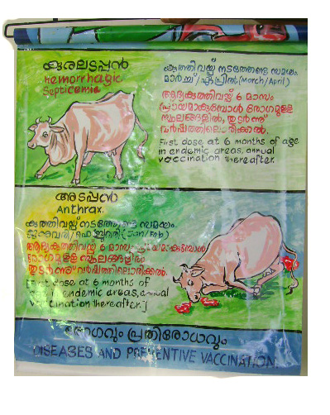
5. ROVAKTRA (Rolling Visual Aid for Knowledge Transfer in Animal Husbandry)

Teaching aid to assist the master trainers to explain a particular topic divided in to sub topics . Each sub topics are represented using pictures and illustrations. Up on finishing the last sub topics other /opposite side of the same role will have a poster designed for describing the benefits of adopting the scientific practices on discussion.

6. OTHER TEACHING AIDS

FLIP BOOK

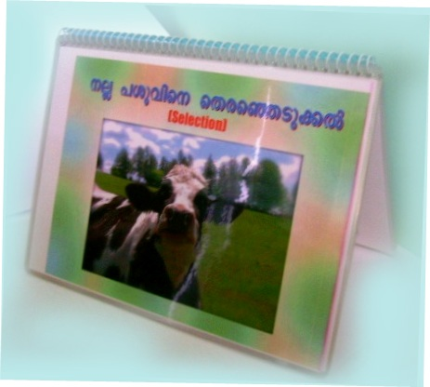

FOLKTRAW

(Folk Music Oriented Knowledge Transfer Audio Communication Method in Animal Husbandry)
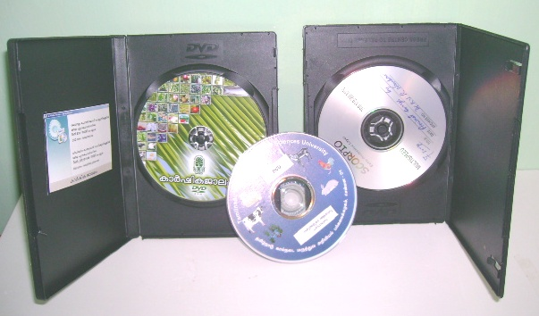

LEAFLETS, BROCHURES AND BOOKLETS HAND BOOK FOR WSHG
MASTER TRAINERS ON CATTLE
REARING

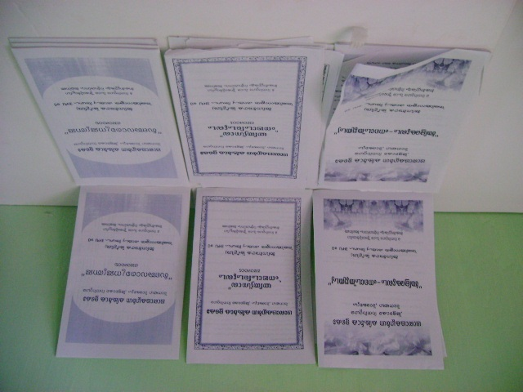
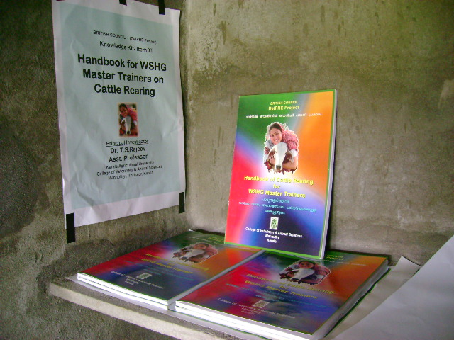

LEARNING MODEL- CATTLE SHED LEARNING MODEL- COW

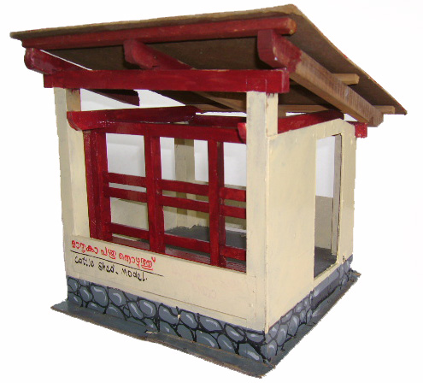
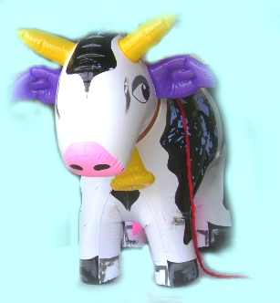

Touch Screen Information Kiosk

Timely and need based transfer of technology, especially location specific, is vital to rural development. Providing right information at right time can usher greater achievements in the farm front. The spurt of visual mass media in recent times points to the fact that it can easily reach common man’s mind easily. The conventional print as well as electronic mass media has its own limitation. Presenting the essential new farm information to the end-users in interactive mode through audio-visual media in virtual support at his immediate premises will greatly lead to an information revolution.
Livestock sector in Kerala provides immediate income generation and opens up sustainable avenues for livelihood to the poor. Nevertheless, improper dissemination of scientific information, defective knowledge delivery and lack of proper critical input-supply management are identified as the major constraints of the animal husbandry entrepreneurs. Government of Kerala has successfully institutionalized farmer services through veterinary dispensaries, hospitals, training centers farms etc. The predominant clinical work of these institutions leads to a week information delivery to the needy livestock farmers.
Keeping the above facts in mind, a project proposal of installing touch screen information kiosks that provide animal husbandry, dairy and allied information at veterinary institutions under 999 Grama Panchayats, is herewith formulated. It can be loaded with the latest information in interactive mode, in such a way that it can be operated by finger touch. The information related to Animal husbandry and allied sectors can be updated regularly and will be available for the use of farmers, entrepreneurs etc visiting the institution at leisure time. It can also function as a teaching and technology transfer aid to the veterinarians and related extension agency.
At this juncture, it may also be a laudable effort from the scientist’s side to make the farmer to directly witness and experience the real life situation through virtual formats in computer screens. It would be definitely beneficial for the farmer to have an interactive video and audio-visual aid at his own premises. The scientists, officers, departmental officials and extension workers etc. can also benefit through this Information KIOSKs since their efforts in technology transfer will be made easy
We have the state of the art expertise at Kerala Veterinary and Animal Sciences University (in the Department of Veterinary & Animal Husbandry Extension) in this regard. We have already installed and commissioned such Touch Screen Information KIOSKs in all the Panchayats of Ollur Assembly Constituency in Thrissur. These are well used by the end-users for the last two years.

What is a TOUCH SCREEN INFORMATION KIOSK? ……
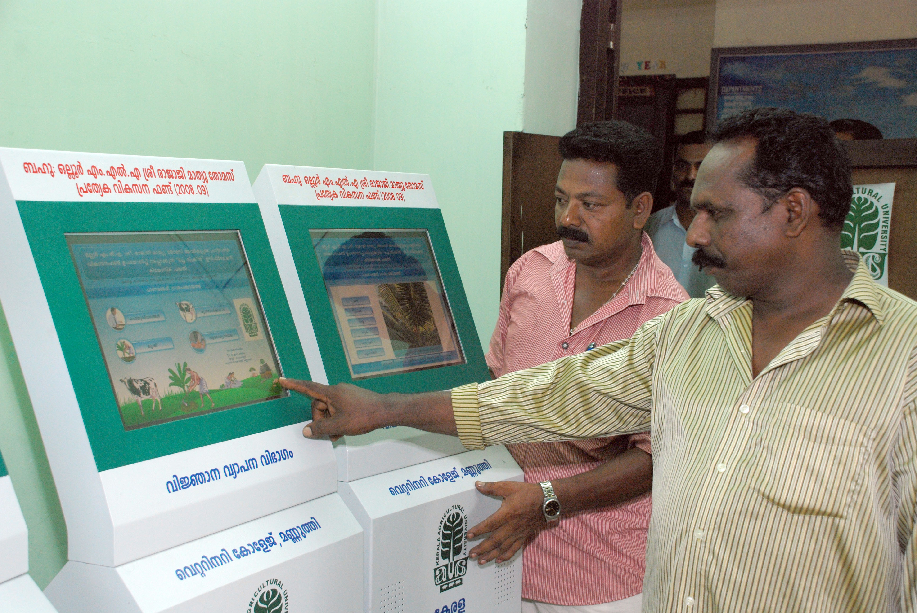
An ordinary Personal computer which displays movies and information’s covered (Like ATM machines)
- The keyboard is the computer screen itself and can be operated by simply touching the relevant part of screen
- The required information is stored as a computer programme in this machine..
- The indicators and precise information displayed in computer screen.
- The required things can be viewed in detail , just by touching on the screen
- Video clippings, PowerPoint and flash programmes are used for this.
- Shall established in centres where a farmer use to visit frequently.(Govt offices, Public places)
- Is an interactive system in which questions can be put forward and answers can be sought
Relevance of Knowledge Dissemination related to Animal Husbandry in LSGs
The latest information in animal husbandry is available in farmers’ finger tips.
  - Malayalam software prepared with videos and uploaded in this kiosk.
  - No special training is needed to use this as in normal personnel computers.
  - All the information will be displayed in sequential order by simple touch.
  - Minute details also can be stored.
  - The latest information and details regarding general and scientific animal management, health care, post production, marketing and animal husbandry practices shall be provided.
  - Accessible to the farmers and other stake holders, at any time in their immediate surroundings.
  - Timely updating and networking of all kiosks in Kerala through web or Internet or broad band.
  - Shall update using expert advice from any part of India, which may be useful for timely marketing of the products, procurement and bypassing middleman.
  - Compatible to the information revolution of the time

Content development for the mass media communication in Animal husbandry extension.

Dr. Sabin George,
Assistant Professor , Dept.of LPM.

Introduction

Journalism is a systematic process of gathering, writing, interpreting,processing and disseminating public opinion, public information and public entertainment for publication in news paper, magazines and broadcast. In the era of knowledge, intensive agriculture farmers need timely and local specific information about their farm practices. Farm journalism can play very crucial role in collection, processing and dissemination of information according to need of the farmers. The farm journalism should be based on scientific research and should be timely, local specific and according to needs of farmers. The success of agricultural development programmes in developing countries largely depends on the nature and extent of use of mass media in mobilization of people for development. The planners in developing countries realize that the development of agriculture could be hastened with the effective use of mass media

Importance of Mass media communication in AH sector.
Information on agriculture, both crop and livestock was communicated among farmers from ancient times. To fulfil this need, mass media like newspapers, magazines radio, TV film and internet play a vital role. What we know about the new information on technologies, public figures and public affairs is largely dependent upon what the mass media told us about it. The major objective of mass media in livestock development is to communicate the feasible farm technologies in such a manner to attract the attention of farmers, help them to understand and remember the message and ultimately facilitate them to take appropriate decision. During the last few decades means of communication have really been revolutionized and the process still continues. In the other hand, weak linkages among extension research, marketing and farmers limit the effectiveness of research and extension to contribute to agricultural development. A study done by the National Sample Survey during June 2005 revealed only six percent of the farmers look up to extension services for any technical information. This indicates the real need and relevance of the mass media information to the farmers. The transfer of technology from the research - to the extension – to the farmers are gradually changing and now more widely opened to an agricultural knowledge and information system. Among the various types of mass media sources, newspapers can support extension by publishing news of various extension activities, guidance and recommendations, achievements, market news, research findings, successful achievements and problems faced by farming community etc. The green revolution and white revolution could not have been come about so quickly without the use of media like print media and radio. Print media like newspapers, journals, bulletin etc. play important role in livestock development. Even today, with the onset of second communication revolution (TV, Computer, E-mail, internet etc.), the importance of print media cannot be ignored. Radio became more popular in the countryside of India. It is enjoying a very high credibility as a source of farm information. It has been observed that farmers who are close to extension work and specialists are better listeners of farm radio program. There are studies also which revealed that villages in which radio forum were organized farmer had greater gain in knowledge of innovation, than in other villages. Various studies also proved that farmers always prefer success stories of other farmers, which is presented in a popular, easy –to-read manner. Next preference they give for question-answer column which they consider as an effective form to get their doubts and queries cleared. Farm educational exposure, which comprising extension contacts and mass media exposure is an important factor for inducing knowledge and adoption as it provides the farmers with necessary knowledge about innovations which help them in making decision for adoption of farm technology. Contact with the mass media should progressively influence men to become modern, seems to be quite logical. The mass media bring information about many aspects of modern living to their audience. Exposure stimulates and justifies the heightened aspirations for education and mobility. All these findings indicate that mass media communication is the most effective method for creating awareness about innovations. These help to accept and adopt new innovations. So, mass media with its combination with other extension methods had been able to raise the level of aspiration of farmer set points and high colour background/border to highlight the prominent issues

Principles of farm journalism

1. Use simple language: Explain the technical terms in short and simple sentence, using common words which have concrete meaning.
2. Structure and arrange arguments clearly: Present ideas in a logical order, clearly distinguishing between the main and the side issues.
3. Make main points brief: Restrict arguments to the main issues clearly directed towards achieving stated goals without unnecessary use of words.
4. Keep important information at the top: Organize the write-up like an inverted pyramid, keeping the most important information at the top.
5. Use lively pictures and photographs: The pictures and photographs should be simple, bold with good composition and good contrast of light and shade, so that the message intended to be conveyed is clearly brought out.
6. Prepare a stimulating write-up: The presentation should be interesting, inspiring, personal and sufficiently diversified to sustain audience interest.

Content of farm journalism
  - Should be simple and precise.
  - Should be timely
  - Should be local specific
  - Should be in local language
  - Should be need based of local people
  - based on facts/scientific research
7. Should be interesting to the end users

Writing Style of Farm Journalism
1. The language of a write-up of a farm journal should be such that it can vibrate the right chord of the target reader. The language should be simple, conspicuous and lucid. Here, we may lay particular emphasis on lucidity, because without lucidity the subject matter will go over the head of the readers of a farm journal.
2. Issues should be narrated in simple, short sentences communicating one thought, preferably in active voice, which can serve the purpose of an example to a farmer.
3. Needless repetition of ideas and wastage of word should be avoided. Jargons and unfamiliar technical terms also should be avoided to the extent possible. Where ever the use of technical terms is unavoidable, the terms should be properly explained at the first instance of its use.
4. The issues which have relevance to target readers should be given prominence.
5. Relevant illustrations, sketches, maps should be used to explain the points.

Content development- a challenge

The ultimate challenge to content development is to meet and fulfil varied information needs of farmers. Agriculture /AH is changing from traditionally subsistence and self-sufficient to market-driven in order to increase rural income and improve rural livelihoods. Not only improved technologies for local traditional farming practices, but new and advanced technologies and even new varieties, new crops being introduced into agricultural practice in order to take advantages of market. Other factors that affect farming, such as climate change leads to vary in temperature and precipitation have posed new challenge for disease management and more, all suggested continuous technology advancement are needed. Up-to-date information thus becomes fundamental to content development for agricultural and rural development.

Content analysis- research findings

The content analysis of Malayalam dailies done by the leading farm journalist Dr. T.P Sethumadhavan revealed that Malayalam dailies provided less than one-fourth space of farm feature pages for publishing animal husbandry information. This necessitated more coverage to animal husbandry sector since its contribution to state’s GDP is comparatively higher. Among different categories of news, even though large animals got more than 50 per cent coverage, buffaloes had been largely neglected. Cows got nearly three-fourth coverage when compared to other large animals. Poultry sector got only one-fourth coverage. Small animals and pet animals occupied 17 per cent and seven per cent space respectively. In general, space provided to different animal husbandry information was obviously less. Integrated farming got coverage of only two per cent. It is a promising practice towards sustainable agriculture. In view of its ecological and economic significance, media should play a significant role in propagating the concept of integrated farming. Relatively more space was allotted for publishing animal husbandry information related to advance in technology in farm feature pages. Of the five modes of presentation news articles occupied maximum column length in all dailies studied. Frequency of occurrence of news articles, illustrations and question answers were found to be more when compared to other modes of presentation. Articles on cows appeared most frequently. But on buffaloes appeared at an interval of 112 days. More than half the number of dairy articles and nearly one-eighth numbers of poultry articles published was seasonal. Low seasonality of poultry articles necessitate that more emphasis should be given to maintain seasonality. Reading easiness of dairy articles was found to be good with an average readability as indicated by Fog index of 5.45. More than half the number of dairy articles was found to be relevant. Even though more than two-third scientific messages of dairy articles were accurate; accuracy of general articles was just above 50 per cent. Scientific messages of management articles got maximum accuracy of 73.4 per cent.

Content development- points to remember
1. The ultimate aim of transfer of technology in AH sector is to ensure the availability of quality animal protein to growing population and livelihood security of the farmers.
2. Ensure the required representation for all farm animal species. This should be targeted at catering the information needs of major section of farmers.
3. Introducing information about new species (e.g. Emu) should be done carefully after market studies.
4. Information regarding pet animals should be included to cater to the needs of pet lovers.
5. Timely information regarding specific management practices for different seasons given.
6. Management practices like feeding, housing, prevention of diseases and bio security can be given more emphasis as it can be practiced by farmers at the farm without delay.
7. Information regarding value addition, marketing and food safety laws.
8. Details of recent research findings, personal experiences, success stories, innovations can find a place in the contents.
9. News stories of activities of farmers groups, markets etc.
10. The changes in the management practices required to meet the disasters and also climate change
11. Emerging diseases can be given space.
12. Details of new breeds/varieties.
13. The importance concepts of integrated farming, organic farming, biodiversity conservation etc.
14. Information on latest schemes and projects of the government.
15. The content of communication can also target people who love farming and also to attract new entrepreneurs to the sector.

Periodical content update , enrichment and analysis is needed to assess the extent of coverage, readability, relevancy, accuracy and reading comprehension.

ICT BASED KNOWLEDGE DISSEMINATION MODELS
IN LIVESTOCK SECTOR

Dr.Deepa Ananth
Asst Professor
Directorate of Entrepreneurship, KVASU
The rapid development in information communication technology (ICT), allowed a revolution in overall education systems, including medicine, veterinary medicine and animal production fields. The advancement in ICT gives new opportunities and challenges for biological scientists and teachers, veterinarians, veterinary technicians, practice managers, veterinary students and veterinary technician students. Numerous electronic tools will increase interaction among the actors involved in agriculture. Information and communication technology (ICT) include any communication device or application, encompassing: Telephone, Radio, Television, Cellular phone, Computers, Networks Satellite systems Hardware and software, The Internet and its applications, WWW, Portals Various services and applications-video conferencing and distance learning, The increased pervasiveness of telecommunication networks have enabled ICT to penetrate rural areas
On a macro level, e-Science (e-Research) draws on extensive digital infrastructure to facilitate collaboration and knowledge exchange at National, Regional and Global level. On a micro level, m-Agriculture is powered by increasingly affordable mobile digital devices such as phones, laptops, and sensors, connect millions of rural people to sources of information. In both cases, ICTs empower individuals and institutions to create, access, and use knowledge and to co web applications directly contribute to research meeting organization, reporting, and dissemination in unprecedented ways. Diffusion of information between farmers and extension agents, farmers and researchers, and extension agencies, among others, is critical to innovation and increased productivity through adoption of better farming practices and technologies. ICT provides new pedagogical models veterinary students including continuous professional education
There are three areas in which ICT can contribute to the livestock sector:

- Improved management of data and information
- Improved services including marketing
- Improved learning and capacity development

Improved management of data and information
Accurate and precise livestock data is required for policy development, strategy formulation, monitoring growth and evaluating impact of policies and programs for growth and sustainable development of the sector. This data and information is required at National, Regional/State, District, Taluk , Village, Community, Household and Farm level.
The purpose for managing this data and information can be for:
- Planning, implementing and monitoring livestock development programs including those for animal improvement and effective natural resources management
- Planning and monitoring livestock production at various levels including village and farms
- Planning and monitoring animal health, bio-safety and food safety disaster management, climate related issues, trade related issues, disease survillence etc
- Planning and monitoring extension and capacity development ,
- Administration, budgeting and accounting of State and Public Enterprises and Services
- Livestock and livestock products marketing and supply chain management
- Planning livestock research
In order to understand the issues of using new ICTs and managing Information systems for livestock production and development, these systems can be classified as

Level of users of information
- Farmers and Animal Owners
- Farming Communities
- Extension Agents
- Service Providers
- Market Intermediaries
- Consumers
- Program Managers
- Researchers and Research Managers
- Policy Makers
Primary category of information processed
- Animal improvement and breeding
- Animal health and disease surveillance
- Animal movement and disease monitoring
- Nutrition and Natural Resources Management
- Farm Management
- Community/Village level livestock and agricultural production systems management
- Disaster management
- Market related
- Planning

Scale of information processed
- Small for individual animal, herds, farm, community, village, research institute
- Medium for a production system, district
- Large such as National, Regional or State
In India, use of personal computers by individual smallholders may not be possible in the near future. However, with lowering of costs and introduction of multi-purpose information kiosks at community and village level such as for health, education, agricultural extension and e-governance, Internet Cafes and even with retail shops, the use of smart cards that store the farmers and animal owners information can be introduced. These smart cards may be the same as issued for e-governance or separate for agriculture and/or livestock. The smart cards may even include a photograph or a digital signature of the animal (e.g. muzzle print) since animal identification is a major issue in India.
Veterinary Services
The most obvious application of new ICT in Veterinary services in India is the use of the cell phone. The cell phone enables the Veterinarian to move from a static location and makes him/her mobile. Coupled to a PDA, the cell phone enables the veterinarian to plan providing services and maintain animal records. If a Geographical Positioning System (GPS), which can locate where his/her services are needed, is included in the PDA, the Veterinarian can save considerable time, cost and improve the range of the services. Good animal records enable a Veterinarian to consult specialists, made easier by the use of the cell phone. With imaging capacities of the i-Mode and WAP cell phones and cheap digital cameras, veterinary consultancy can further be improved. This is a form of veterinary tele-medicine that India has not made attempts to exploit.
The ability to collect, collate and integrate data through information systems enables the provision of preventive veterinary medicine, herd and flock health at the village level. The issue of PDAs, to veterinarians and extension agents to record data and use information locally can bring about the application of preventive veterinary medicine in India. The establishment of call centers at veterinary hospitals and Institutions is a largely ignored aspect of providing veterinary services.

Other Livestock Services
Similar to ICT application for animal improvement, low cost feeding regimes using locally available feed ingredients and monitoring nutritional status of animals can be developed. There can also be agencies to provide the feed materials and market linkage to monitor supply chain of feed and feed ingredients. This can also be linked with the ecological zones and climate in tune with demand and adequacy of ingredients.

Health related issues
In the era where, food security and safety issues are emerging the importance of hygienic production, preparation and marketing of food acquire importance. ICT can enable and ensure the adequacy and timely assessment of production demand and supply of livestock production systems. Labeling for quality, food and bio-safety and consumer assurance is emerging as an essential information service for consumers participating in global animal products trade. Integration of ICT with livestock production and marketing are gaining importance. One of the most important issues in the marketing of animal products, especially meat, is the ability to trace back at various levels, farm, processor, market intermediary, packager and ultimately exporting country. The use of ICT is essential to implement a trace back system

Marketing
As part of National Agriculture Policy, Government of India is implementing Market led extension programme in the country. Market Information, Production information, Price information, forecasting, market intelligence, farmers advisory services, Networking of Markets through ICTs Commodity Exchanges, Futures Trade Value chain management Knowledge intensive post-harvest management, Traceability , quality and certification, Supply chain management are some of the examples. Easier availability of market information, including prices and trends, have potential to change the structure of the livestock production system in India.

Improved Learning and Capacity development
To exploit the potential of livestock production by smallholders huge efforts in capacity building are required. The entire livestock system need to disseminate innovations across the commodity chain.
Veterinary and Animal science universities in the country started activities related to ICT in formal education. ICT, especially computer-based presentations, have been used as part the teaching method. However, there are no signs yet where the advantages of ICT such as the use of video clips, simulation and digital models have been used in the pedagogy of veterinary and animal science education. The Universities need to provide learning by enlarging their client base through open and distance learning to field veterinarians and livestock professionals, livestock producers and those involved in the entire commodity supply chain.
One of the most critical areas in using ICT to benefit smallholder farmers is to enable them to learn. India has been a pioneer in using ICT for rural development with examples such as the M.S. Swaminathan Research Foundation's (MSSRF) Information Villages, Gyandoot, Warana project, Rajiv Gandhi College of Veterinary and Animal Sciences, Puthucherry, etc.

ICTs Applications in India
Central Government Initiatives are DAC-NATP, DACNET, AGMARKNET, KCC DARE-ARIS, ATIC, Ministry of CIT(NIC)- CICs
State Government Supported initiatives- Rajasthan- Jan Mitra,Gujarat-GAU-SAT-KRU, M.P.- Gyandoot, Maharashtra-Maha-Agrinet, A.P.-Rural e-Seva, Karnataka-Rhythu Sampark Kendras and Bhoomi, Kerala- Kissan Kerala, Akshaya Kendras
Corporate Sector Initiatives: e-Chaupals of ITC-IBD, Tata Kisan Kendras of Tata Chemicals, Parry’s Corners of EID Parry and Chirag Kendras of n-Logue NGOs
Private Sector: Information Village-MSSRF, Drishti.com, Agriwatch.com, TARA Kendras.

Conclusion
The use of ICT for sustainable growth in livestock production in India is not a matter of providing computers and Internet connectivity. It is of developing effective information systems for planning and monitoring livestock development programs, improving livestock services and enabling learning for capacity development that use ICT effectively and efficiently.

